IPNI Global Maize Project
International Plant Nutrition Institute
Foundation for Agronomic Research

Background
Demand for increased maize production to meet the food, feed, and fuel needs of expanding world populations challenges us to make the best, most efficient use of every parcel of land upon which maize is grown. Production must double within the next 20 years to meet that challenge. Genetic improvements can be expected to account for about half of that increased production, but to realize the potential of the improved genetics, other components of the management system must also be improved. Nutrient management is a major part of the “management half”. New fertilizer materials, new methods of application and timing, and new understanding of the nutrient management system will help guide farmers and their advisers to put the right products, at the right rate, in the right place, and at the right time to improve yields and at the same time protect the environmental resources associated with the production field. The goal is to build toward an Ecological Intensification (EI) management system that supports these goals.
Global Maize Centers (A-Sites)
IPNI Global Maize Centers are located in 14 major maize production regions of the world. Scientists associated with each of these Centers form a virtual network of researchers studying all aspects of maize production. Each Center Team is defining the common management system for their respective region, then they will determine the potential yield for that region, and thus define the respective “yield gap”. With that information, they will work to determine what practices and inputs need to be modified to attempt to narrow that yield and move producers toward attaining their potential production levels.
Locations of the fourteen Global Maize Centers are shown in this map. 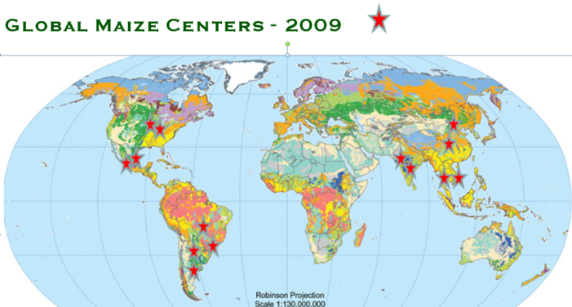
For some of the Global Maize Centers, long-term management systems will be put in place to demonstrate the current farmer practice (CFP) management system and the Ecological Intensification (EI) management system for that site. These demonstrations, set up in replicated design, will be monitored over several years to track differences in agronomic responses, economics, and environmental impacts. This will enable us to track the management systems over time. As technologies change, both the CFP and EI systems will be modified to maintain the relative comparison.
Research Sites (B-Sites)
Associated with the main system demonstrations will be specific research projects where the local scientists study different products and practices that may contribute to improvements in maize yield. As results of these studies are reported, they will guide decisions on new practices to be incorporated into the CFP and EI management systems. Many of these projects will be existing, ongoing studies in the area of the Global Maize Center. As specific questions arise among the Global Maize Team, they will implement specific research projects to address those questions.

On-Farm Sites (C-Sites)
Progress in agronomic systems is ultimately measured by the rate of adoption of new practices and the resulting impact on overall production. To facilitate fine-tuning the management systems and getting them in place on farmers’ fields, Global Maize on-farm comparisons will be used. Built around cooperating farmers and their advisers, a network of On-Farm Trials will be set up to collect data to create a local database. The protocol to be used is a series of simple “omission plots”, where a complete management system is compared to plots with selected practices or products dropped out.
Data Management
The IPNI Global Maize program will feature a data sharing and management system, the Global Maize Information Network, which will be accessible by all of the Global Maize participants. This system will allow combining of databases from all of the Global Maize A, B, and C Sites, sharing of analytical software and procedures, and sharing of decision support tools. Soils and weather data for the research and demonstration sites, along with crop data collected from the project will be available for cooperative work among participants. A project website will facilitate communication and data sharing, and will provide access to public information about the project.
Funding
Base support from the International Plant Nutrition Institute has helped establish the basic infrastructure of the Global Maize program, but funding is being sought to fully develop the Global Maize Centers, establish the long-term management comparisons and specific research, and to build the network of On-Farm management component evaluations. Support is needed from agribusinesses, government agencies, producer organizations, and individuals at the local, national, and international level s.

Contact Us
For more information on the Global Maize Project and how you may become a part of this project, please refer to our website, http://www.farmresearch.com/globalmaize, or contact one of the project leaders:

Dr. Harold Reetz
IPNI/FAR
107 S. State Street
Monticello, Illinois 61856
Phone: 217-762-2074
e-mail: hreetz@ipni.net

Dr. T. Scott Murrell
IPNI
2242 Edison Drive
West Lafayette, Indiana 47906
Phone: 765-463-1012
e-mail: smurrell@ipni.net

=============================================================================

Global Maize will support narrowing the yield gap for maize producers throughout the world, regardless of their soil, climate, financial, and human resources, and help to meet the global demands for maize production for food, feed, and fuel, while striving to reduce the environmental footprint of the maize production systems.

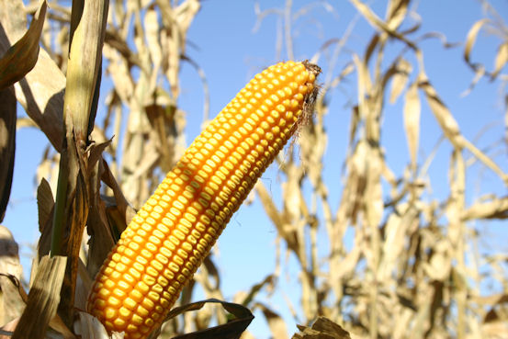

Cassman, K.G. 1999. Ecological intensification of cereal production systems: Yield potential, soil quality, and precision agriculture. Proc. Natl. Acad. Sci. 96:5952-5959.

