Annual Report

Evaluating the 4R Nutrient Stewardship Concept and Certification Program in the Western Lake Erie Basin

Submitted by

Kevin King
1/26/2017

Interpretive Summary: Since the mid 1990s, soluble phosphorus (P) entering Lake Erie has steadily increased, promoting harmful and nuisance algal blooms (HNABs). The focus of this excess P delivery has been on agriculture. The 4R principles of nutrient stewardship have been promoted in the WLEB and adoption is gaining momentum with nearly 2,000,000 acres within the Western Basin being managed by one of 37 4R certified retailer/service providers within the Lake Erie watershed. However, understanding and quantifying the water quality benefits of the 4R program need to be accomplished. A multifaceted research project was initiated in July 2014 to quantify the edge-of-field and watershed scale effects of the 4R program. The project includes: data collection from edge-of-field and watershed scales; watershed and in-lake modeling; a socioeconomic assessment of producers; a triple bottom line assessment of the 4R program including a survey of retailers; and education and outreach. Three paired edge-of-field (EOF) data collection sites have been established and 15 additional EOF site within and outside of the WLEB have been leveraged for assessment of best management practices including the 4Rs. A broad brush assessment of prevailing management practices on those EOF sites indicates that the 4R practices are directionally correct for reducing P to WLEB. Watershed scale assessments will be based on water quality data collection through the National Center for Water Quality Research, which has been in place since the mid 1970s. Initial assessments indicate that a comparison between watersheds is possible; however, given the widespread extent to which the 4R initiative has been adopted, the watershed analysis will be based on percentage of acres affected within each watershed. Identification of the number of acres under 4R management within each monitored watershed is underway. SWAT models for three major watersheds that comprise the WLEB have been populated and different scenarios have and are being run to project and assess the benefits of the 4R initiative. A third producer survey within the WLEB basin was sent out in January to assess the knowledge and adoption of 4R practices. Current findings indicate that a majority (>80%) of producers are aware of the 4R initiative and between 60% and 90% are willing to adopt a new management practice. However, economic barriers may prevent the adoption of some practices. Additionally, outreach and promotion of the 4R program have occurred at multiple meetings and venues. A video has been produced that highlight the 4R initiative and promotes the benefits of subsurface placement.

Objective 1: To monitor the impacts of 4R Nutrient Stewardship practices and the 4R Certification Program on crop productivity, nutrient losses, and biotic integrity from select fields, streams, and watersheds in the WLEB.

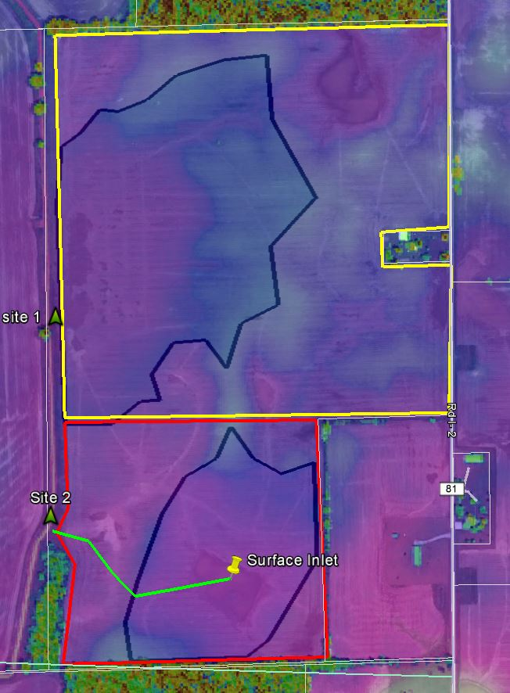
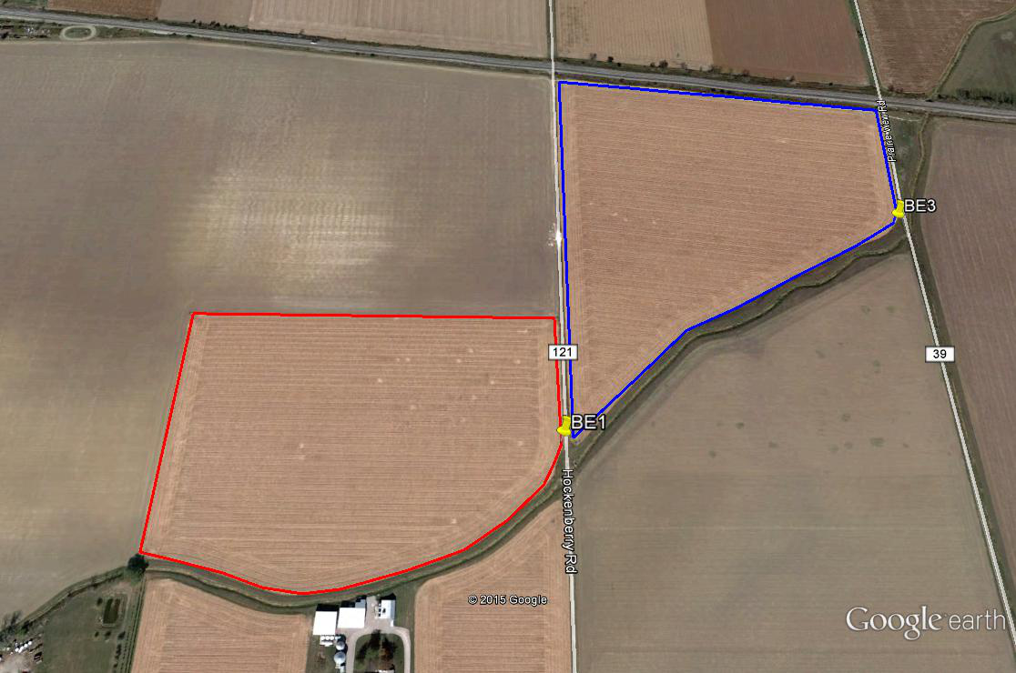
C
A
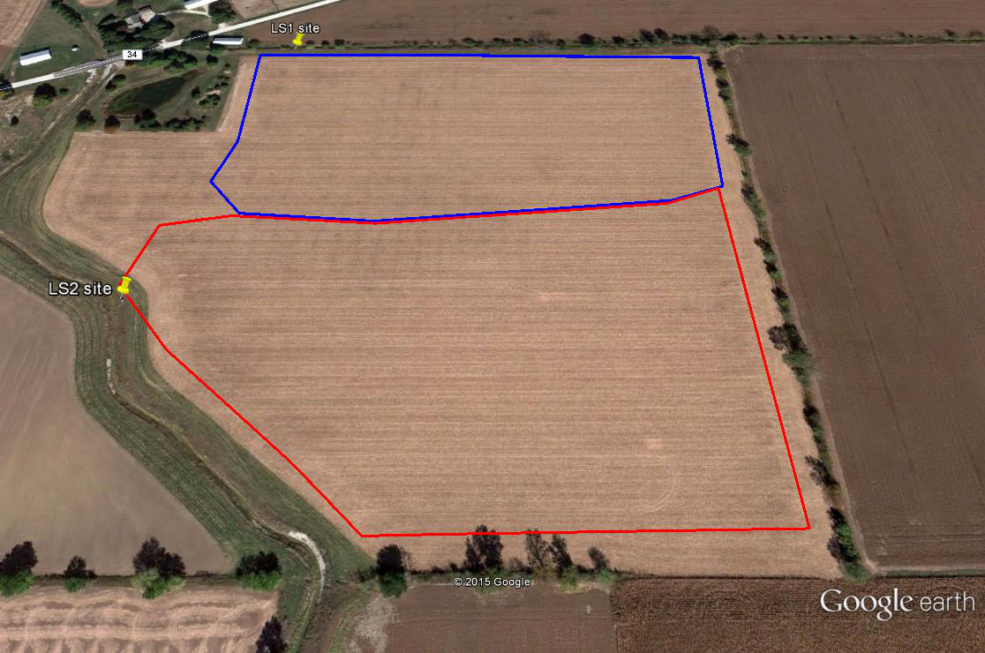
B
Figure 1. Outline of fields in Ohio (A&B) and Indiana (C) being used for edge-of-field monitoring to support the 4R Research Project.
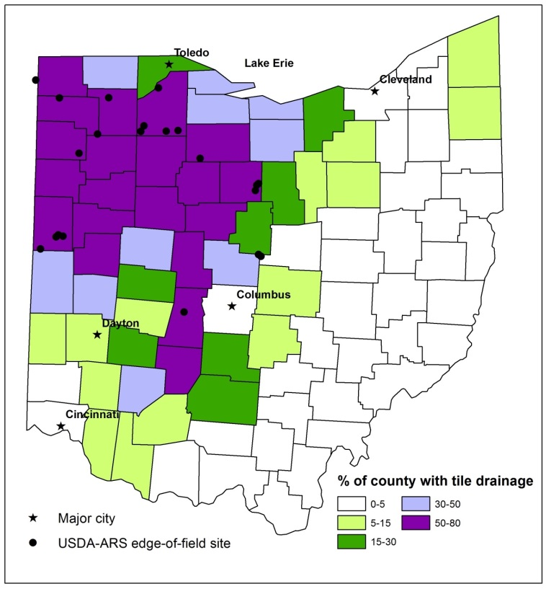
Figure 2. Location of paired, 4R and leveraged ARS EOF sites being used to assess 4R practices.

Edge-of-Field (EOF) Research:
Two sites in Ohio and one in Indiana were identified for combined surface and subsurface EOF monitoring (Figure 1A, 1B, and 1C). The Ohio sites are located in Wood County in the Portage River Watershed. The Indiana site is located in Steuben County on the Ohio-Indiana border. All three sites are representative of crop production agricultural systems in the tile drained landscape of the WLEB. Instrumentation was completed at the Ohio sites in Jan/Feb 2015 and the Indiana site in Nov/Dec 2015. In addition to these three sites, additional EOF sites (Figure 2) also have 4R related research ongoing and those data are being leveraged as part of this research effort.

Accomplishments/Progress:

- Continued to measure discharge and water quality from 20 paired EOF sites.

- Summarized 2017 water year discharge and loading data.

- In the process of developing water, N, and P budgets/balances for each EOF site.

- Visited with all cooperating producers to assess ongoing or newly planned treatments. Summary of those planned treatments follow:

- A: Alfalfa was planted in west field in fall 2016 and at least one cutting was made in WY17. The east field was soybeans in 2017 and will go to corn in 2018. Bill is interested in systematically tiling the east portion of the field, maybe in 2018 although when I visited with him he indicated he may be willing to wait until 2019.
- B: A timing (fall vs spring manure application) study was initiated in Fall 2016. In 2016, one of the fields received manure application the pair received the same amount in spring 2017. We need to look at this data to determine if an immediate impact could be realized.
- C: The primary treatment is to look at the effect of gypsum. Cover crops are part of the normal management and have been planted across both fields. Gypsum was applied to the north site while the south site did not receive gypsum. This started in Fall 2016.
- D: Sorghum sudan was planted in the entire field but only an application prior to planting and after the last cutting were made which mimicked applications with corn silage.
- E: New study will be to apply normal fertility rates on one field and apply nothing to second field until crop yields show an impact. This will be an attempt to identify critical P level.
- F: In 2015, P source (manure vs MAP) was evaluated and data collected through harvest 2017. In fall 2017, alfalfa was planted on the south field and the north field will remain in a corn-wheat rotation. This will provide somewhat of a replication to another site.
- G: Following wheat harvest in 2017, a rate study was initiated. 7000 gallons dairy manure was applied on the north field. Approximately a month later 7000 gallons was applied to the entire field creating a rate test of 7000 gallons vs 14000 gallons applied in a split application. On top of that and on two of the four drain tiles was applied a cover crop, creating a rate and cover crop paired study.
- H: Conversion to no-till and cover crops was initiated in fall 2015. The north field is being converted and will continue to serve as the treatment (no-till and cover crops) while the south field will remain the control, in this case generally some tillage every year.
- I: This is not a true paired study as a large application of P was made to the south field in following wheat harvest in 2017. Depending on when irrigation becomes available we may be able to compare to north field. However, north field is scheduled to be fitted with center pivot irrigation. Comparison between fields may be limited to hydrology, at least from a paired statistic.
- J: Following harvest this season we will test DWM with cover crops on east field compared to no DWM or cover crops on the west. Cropping will remain same across both fields.
- K: Vegetables (peppers or cabbage) will be introduced in growing season 2019. After soybean harvest this year, wheat will be planted in the entire field. Following wheat harvest in 2018, tile on large portion of the field will be split (I think to 20 ft) to improve drainage. Additionally, poultry litter will be applied to large portion of field to increase P levels for vegetables. The small portion of the field will remain at 40 ft spacing and in a traditional rotation.
- L: Placement study. Treatment field will be east field while west will remain the control. After soybean harvest this fall, the entire field will be tilled. In the spring, fertilizer application will be made and incorporated on the west field and left on the surface of the east field. There was some confusion as the whether or not the west field would receive any tillage and we need to follow up and confirm one way or the other.
- M: Cover crops across both fields. A larger swine manure application will go across both fields following harvest this season and then the south sites will not have any application over the next rotation while the north will receive normal applications. After this treatment period (one crop rotation) intent is to introduce intensive grazing of cover crops in between field crops.
- N: DWM study. South field will operate in free drainage mode while north field will operate in DWM year round. We will be managing the structures and letting producer know when the boards are set and pulled. After this study, we may want to look at raising south structure to surface to simulate a no tile scenario if producer is okay with it.
- O: No decision was made, but we decided the treatment field would be the 58 acre field by the barn. Leaning toward a 4 year application of nutrients (58 acre field) vs a 2 year application on 300 acre field. Nutrient source could be poultry litter. Will need to visit with them once harvest is completed. Treatment will not take place until spring.
- P: Treatment will be tillage of some sort with treatment field being the south collection point. Need to follow up with them about extent and type of tillage.
- Q: South field will be in line ripped (16 to 18”) and then disk ripped this fall while north field no tillage. In spring prior to soybean planting south field cultivate and north field possible vertical tillage.
- R: Will most likely try to increase P content on south field in order to test steel slag filter
- S: Treatment field will be north field and will look at variable rate application in combination with no-till and cover crops. Still need one more year of baseline data.
- T: Treatment field will be north field and treatment will involve implementation of Glenn Arnold approach to in season manure application (timing).
- U: Treatment field will be south field and it will be to apply no P until a yield difference is noted. This will provide a replicate to another paired site based on rate.

Presentations led by or contributions from edge of field research team:
- Williams, M.R. Hydrologic and biogeochemical controls on phosphorus export in artificially drained landscapes. Delmarva Conservation Partnership, Easton, MD (1/19/2017).
- Williams, M.R. Phosphorus losses in surface runoff and tile drainage in the Western Lake Erie Basin. Partnership for Agricultural Resource Management, webinar (1/31/2017).
- Williams, M.R., and K.W. King. Decreasing phosphorus losses with drainage water management practices. Lake Erie Millennium Network Binational Research and Monitoring Conference. Windsor, Ontario, Canada (2/21/2017).
- Williams, M.R., K.W. King, D.R. Smith, S.J. Livingston, C. Huang. Understanding hydrologic pathways and assessing conservation benefits in the Western Lake Erie Basin. University Council on Water Resources, Fort Collins, CO (6/14/2017).
- Williams, M.R., S.J. Livingston, C.J. Penn, D.R. Smith, K.W. King, C. Huang. Dominant mechanisms for nutrient delivery across nested headwater watersheds in the Western Lake Erie Basin. ASABE Annual Meeting, Spokane, WA (7/17/2017).
- Williams, M.R., K.W. King, E.W. Duncan, L.A. Pease, C.J. Penn. Effect of fertilizer placement on phosphorus leaching in fine-textured soils. ASABE Annual Meeting, Spokane, WA (7/18/2017).
- Williams, M.R., K.W. King, E.W. Duncan, L.A. Pease, C.J. Penn. Phosphorus leaching in fine-textured soils: Effect of fertilizer placement. SWCS Annual Meeting, Madison, WI (7/31/2017).
- Williams, M.R., S.J. Livingston, C.J. Penn, D.R. Smith, K.W. King, C. Huang. Dominant mechanisms for nutrient delivery across nested headwater watersheds in the Western Lake Erie Basin. SWCS Annual Meeting, Madison, WI (8/1/2017).
- Williams, M.R., and K.W. King. Effect of tillage and fertilizer placement on phosphorus loss. Ontario Certified Crop Advisors Soil and Water Day, Guelph, Ontario, Canada (11/8/2017).
- Williams, M.R., and K.W. King. Effect of tillage and fertilizer placement on phosphorus loss. Office of the Indiana State Chemist, Lafayette, IN (12/19/2017).
- Duncan, E.W., K.King, L. Pease. March 2017. Phosphorus movement as it relates to soil stratification. Conservation Tillage & Technology Conference, Ada Ohio.
- Duncan, E.W., K.King, L. Pease. May 2017. Phosphorus stratification and edge of field P losses in the Western Lake Erie Basin. Tri society meetings (ASA, CSSA, SSSA), Tampa, FL.
- Duncan, E.W., K.King, L. Pease. August 2017. Edge of field research to assess agricultural management practices. NOAA National Weather Service, Ft. Wayne Indiana.
- Duncan, E.W., K.King, L. Pease, M. Williams. August 2017. Reducing nutrient movement: data from edge of field studies. Manure Science Review, Paulding Ohio.
- Duncan, E.W., K.King, L. Pease. October 2017. Soil test phosphorus: A proxy for P risk in tile drained landscapes. International Interdisciplinary Conference on Land Use and Water Quality: Effect of Agriculture on the Environment, The Hague, The Netherlands.
- Duncan, E.W., K.King, L. Pease, M. Williams. November 2017. Reducing nutrient movement: data from edge of field studies. Extension In service Day-London, OH.
- Pease et al. “Findings from the Edge-of-Field Research Network,” Dunkirk, OH. Oct 6, 2017. Audience: 70 Ohio Farm Bureau Employees (Discovery Farms Tour)
- Pease et al. “Findings from the Edge-of-Field Research Network,” Dunkirk, OH. Sep 22, 2017. Audience: 45 citizens from the Toledo, Ohio metropolitan area (Discovery Farms Tour)
- Pease et al. “Nutrient Reduction Practices in Ohio,” NRCS Area Research Conservationists & Engineers Meeting, London, OH. Mar 22, 2017. Audience: 50 USDA-NRCS and Ohio Department of Agriculture engineers
- Pease et al. “Benefits of Drainage Water Management,” Conservation Tillage & Technology Conference, Ada, OH. Mar 8, 2017. Audience: 80 Farmers, Extension Agents, and Certified Crop Advisors
- Pease, L.A., K.W. King, M.R. Williams, G.A. LaBarge, E.W. Duncan, and N.R. Fausey. “Phosphorus export from artificially drained fields across the Eastern Corn Belt,” Annual Meeting of the Soil and Water Conservation Society, Madison, WI. Jul 30 to Aug 2, 2017.
- Pease, L.A., K.W. King, M.R. Williams, G.A. LaBarge, E.W. Duncan, and N.R. Fausey. “Phosphorus export from artificially drained fields across the Eastern Corn Belt,” American Society of Agricultural and Biological Engineers Annual International Meeting, Spokane, WA. Jul 16 to 19, 2017.
- Pease, L.A., K.W. King, M.R. Williams, G.A. LaBarge, E.W. Duncan, and N.R. Fausey. “Phosphorus export from artificially drained fields across the Eastern Corn Belt,” International Interdisciplinary Conference on Land Use and Water Quality: Effect of Agriculture on the Environment, The Hague, the Netherlands. May 29 to Jun 1, 2017.
- Pease, L.A., K.W. King, C.J. Penn, L.C. Brown, and M.R. Williams. “Edge-of-Field Phosphorus Reduction Practices in Ohio,” North Central Extension and Research Activity (NCERA) 217 and Agricultural Drainage Management Systems Task Force (ADMS TF) Meeting, Champaign, IL. Mar 29 to 30, 2017.
- King et al. Feb 2: Provided a presentation (Using edge-of-field research to assess agricultural management practices) to Concentrated Animal Feeding Advisory Committee (30 to 35 researchers, state and local governments, producers, stakeholders) in Reynoldsburg, OH.
- King et al. Feb 13 – Provided presentation (Using edge-of-field research to assess agricultural management practices: the case for subsurface nutrient placement) at the Agricultural Equipment Technology Conference to 50 equipment manufacturers, engineers, retailers (Louisville, KY)
- King et al. Feb 23 – Provided presentation (Managing Water for Resilient Agriculture) at the ADS OHIO Agriculture conference to 75 land improvement contractors, producers, pipe manufacturers and retailers (Findlay, OH)
- King et al. Mar 8 – Provided presentation (Update on edge-of-field research and effects of agricultural management practices) at Conservation Tillage and Technology Conference (CTTC) to approximately 100 producers, CCAs, extension specialists (Ada, OH)
- King et al. Mar 9 - Provided presentation (Using edge-of-field research to assess agricultural management practices) at BMPs for Reducing P Losses from Cropland: State of the Science conference to 90 producers, CCAs, stakeholders, extension (Tiffin, OH)
- King et al. April 19 - Provided presentation (Using edge-of-field research to assess agricultural management practices) at Lake Erie Annex 4 meeting to 30 US and Canadian Lake Erie stakeholders (webinar)
- King et al. May 18, 2017 – provided presentation, “ Using edge-of-field research to assess conservation management” at Edge-of-field stakeholder focus group to 20 Commodity, Agribusiness, NGO leads (London, OH).
- King et al. Jun 2 – provided field tour and overview of edge-of-field research to 25 county commissioners and staffs at Ohio Farm Bureau Demonstration Farms event (Dunkirk, OH)
- King et al. July 26 – provided presentation “Update on edge-of-field P research to address Lake Erie algal blooms” to 100+ farmers and producers at Field to Lake conference (Archbold, OH)
- King et al. Aug 1 – provided presentation “Insights on conservation and management from edge-of-field research and assessment in Ohio” to 40 scientists, extension, agency, and NGOs at Great Lakes Symposium (Madison, WI).
- King et al. Aug 10 – Provided presentation “Effects of agricultural management on edge-of-field nutrient losses” to 85 producers at Williams County field day (Ney, OH).
- King et al. Aug 16 – Provided field tour and presentation “Overview of edge-of-field research in Western Lake Erie Basin” to 90 researchers as part of SERA-17 conference (Oregon, OH).
- King et al. Aug 17 – provided field tour and presentation “Using edge-of-field research to assess conservation management practices” to Canadian Minister of Natural Resources and Ohio Directors of Ohio EPA, Ohio Dept. of Agriculture, and Ohio Dept. of Natural Resources and selected staff (Wood County, OH)
- King et al. Sep 13 – provided presentation “Update on edge-of-field research in Ohio” to 80 fertilizer retailers at the 4R nutrient stewardship information field day (London, OH)
- King et al. Oct 24 – provided presentation (Evaluating the 4R nutrient stewardship concept and certification program in the Western Lake Erie Basin) to approximately 75 fertilizer industry, certified crop consultants, researchers, and extenstion specialists (Tampa, FL).
- King et al. Dec 13 – provided webinar (Using edge of field research to assess agricultural management practices) as part of ASA-SSSA education series on Advanced 4Rs scenario-based training to 25 certified crop advisors (CCAs).
- King et al. Dec 19 – provided presentation “Using edge-of-field research to assess conservation management and water quality” to 50 producers, commodity staff, and ag industry at Ohio Corn, Wheat, and Soybean Annual Growers Meeting (Columbus, OH)

Watershed Monitoring and Biotic Measurements:
Accomplishments
- As with last year, we deployed, calibrated, and maintained two YSI EXO2 sondes collecting dissolved oxygen, pH, turbidity, temperature, and conductivity data at the Sandusky and Portage River sampling locations; deployed miniDOT sensors collecting dissolved oxygen and temperature data at the Blanchard, Tiffin, Maumee, Rock, and Honey sampling locations; and deployed Odyssey PAR sensors at each of the above stations.
- Started preliminary analysis of the extent of 4R certification by watershed to compare with nutrient export data. That effort will continue this year.
- The 2017 water year data collection was recently updated for all HTLP watersheds, including those data used in this project. Data are available for download at https://ncwqr.org/monitoring/data/
- The 2016 water year data collection was recently updated for all HTLP watersheds, including those data used in this project. Data are available for download at www.heidelberg.edu/ncwqr
Synergistic Activities
- Attended the CWN OMAFRA Nutrient Management Workshop on July 27, 2017 in Toronto, ON. This workshop brought together a group of experts in agricultural phosphorus runoff to help provide input to the Canadian Water Network and OMAFRA for drafting the GLWQA Domestic Action Plan to meet phosphorus load reduction goals set by Annex 4.
- Attended the Sustainable Phosphorus Research Coordination Network Meeting on May 16, 2017 in Washington, DC. The goal of this network was to pull together ideas on how we can more sustainably use and recycle phosphorus in a holistic way. This group worked on a phosphorus cascade conceptual paper, a paper linking ecosystem services to farm management, and a paper to revise and update the conceptual models of soil phosphorus cycling.
- Participated in a panel discussion on water quality at the Midwest Assoc. of State Departments of Agriculture (MASDA) annual meeting on June 20, 2017 at Middle Bass Island. The panel discussed current issues in Lake Erie and what is needed to improve water quality.
- Facilitated on a nutrient bus tour organized by Seneca and Wood County Conservation Districts. The goal of the tour was to tour water quality solutions, including an NCWQR monitoring site, a state-of-the-art automated dairy operation, agricultural equipment dealer, and a biosludge facility. ~120 people attended including politicians, students, farmers, and citizens. November 14, 2017.
Presentations, All mention 4Rs, bolded are more important
- 16 November 2017 The potential influence of climate change on nutrient runoff and algal blooms in Lake Erie. Webinar for the Sustainable Phosphorus Alliance.
- 15 November 2017 Phosphorus dynamics in Lake Erie tributaries. TMACOG Tech symposium “Agricultural Actions For Clean Water in the Western Lake Erie Basin.” Monroe, MI.
- 14 November 2017 Phosphorus dynamics in Lake Erie tributaries. Nutrient Bus Tour organized in part by Seneca Conservation District. Gibsonburg, OH.
- 8 November 2017 Water Quality of the Blanchard River: Recent research from the National Center for Water Quality Research. Blanchard River Watershed Partnership Annual Meeting. Findlay, OH.
- 25 October 2017 The summer of 2017: Phosphorus loading and bloom recap. TMACOG Watershed group meeting. Toledo, OH.
- 6 October 2017 Contributions from the National Center for Water Quality Research to the understanding of Lake Erie and beyond. Univ of Findlay Student NCWQR tour. Tiffin, OH.
- 4 October 2017. Phosphorus and Lake Erie: Perspectives from between the land and lake. Invited Seminar Dept of Geosciences, University of Akron. Akron, OH.
- 28 September Phosphorus and Lake Erie: Perspectives from between the land and lake. Land To Lake Conference. Defiance, OH.
- 26 September 2017 Phosphorus and Lake Erie: Perspectives from between the land and lake. Ohio AWWA Conference. Toledo, OH.
- 30 August Linking 4R nutrient stewardship at the farm to water quality from the field to watershed. Nutrient Stewardship Council meeting. Webinar.
- 18 August Contributions from the National Center for Water Quality Research to the understanding of Lake Erie and beyond. Findlay-Hancock County Chamber Agri-Business committee NCWQR tour. Tiffin, OH
- 15 August 2017 Phosphorus Along the Land to Lake Continuum. Annual SERA-17 meeting. Oregon, OH.
- 24 July 2017 Maumee nutrient loading and 2017 HAB forecast. Western Lake Erie Basin Partnership Meeting. Toledo, OH.
- 13 July 2017 Maumee nutrient loading March 1 – July 31, 2017. 2017 HAB Forecast at OSU Stone Laboratory. Put-in-Bay, OH.
- 8 June 2017 Identifying how to reduce phosphorus loads from Lake Erie agricultural tributaries. Society for Freshwater Sciences Annual Meeting. Raleigh, NC.
- 5-6 April 2017 Current monitoring of Lake Erie tributaries. GLWQA Annex 4 Loading Workshop. Ann Arbor, MI.
- 17 March 2017 Updates from the National Center for Water Quality Research at Heidelberg University. Ohio Water Resource council. Columbus, OH.
- 8 March 2017 The Heidelberg Tributary Loading Program and Soil Stratification Sampling: State of the WLEB watersheds. BMPS for reducing P losses from Cropland: State of the Science symposium. Tiffin, OH.
- 7 March 2017 Agricultural Phosphorus and Lake Erie: Perspectives from between the land and lake. Great Lakes Conference at MSU. East Lansing, MI.
- 2 March 2017 The Heidelberg Tributary Loading Program: Sandusky River. Sandusky River Watershed Coalition annual meeting. Tiffin, OH.
- 1 March 2017 The Heidelberg Tributary Loading Program: Keeping a Finger on the Pulse of Ohio’s Watersheds. Certified Livestock Manager Training. Reynoldsburg, OH.
- 28 February 2017 The Heidelberg Tributary Loading Program: Patterns relevant to water safety. Tiffin area safety council. Tiffin, OH.
- 21 February 2017 Sources, transformation, and measurement of dissolved reactive phosphorus in Lake Erie tributaries. Lake Erie Millenium Network meeting. Windsor, ON
- 15-16 February 2017 Agricultural Phosphorus and Lake Erie. EPA Region 7 HAB Workshop. Lenexa, KS.
- 9 February 2017 Phosphorus and Lake Erie. Wood County Park District. Perrysburg, OH

Objective 2: To model the environmental benefits in Lake Erie (turbidity and HABs) following various levels of implementation of 4R Nutrient Stewardship practices and the 4R Certification Program in three WLEB agricultural watersheds.
Maumee River Basin SWAT and WLEEM Model (LimnoTech: Todd Redder):
General Notes:
- SWAT model development, calibration, and application activities have also been supported by grants provided by the Erb Family Foundation and the Ohio Department of Higher Education (HABRI initiative), as well as by a project funded by Field to Market® (related to its Fieldprint® calculator).
- “Western Lake Erie Ecosystem Model” (WLEEM) development, calibration, and application activities have been co-supported by several other projects funded by NSF, CSMI, and USEPA.
Soil & Water Assessment Tool (SWAT) – Maumee River Basin
- Application to preliminary BMP scenarios:
- In fall 2017 we ran an additional suite of BMP scenarios, including several scenarios with a 4R focus (primarily related to placement and timing - see scenarios 1, 4, 5, etc. in Attachment 1).

- Model integration & testing with edge of field (EOF) datasets:
- We continued to work with Dr. Kevin King and his team to acquire EOF datasets and management information for calendar years 2015 and 2016 for several EOF sites in Ohio.
- Expanded configuration and testing of the SWAT model for a total of 9 paired sites (18 fields total) in spring-fall 2017. We will be continuing to expand and refine these model applications throughout 2018, working closely with Dr. King and his team on data interpretation and conceptual model development.
- Results of current EOF model applications are included in the SERA-17 presentation (see Attachment 2)

Western Lake Erie Ecosystem Model (WLEEM)
- Model application & sensitivity analysis:
- Conducted further development and evaluation of the WLEEM modeling framework.

- Conducted additional sensitivity analysis with model to explore impact of key algal growth and sediment-related parameters on predicted cyanobacteria biomass.

Publications:
- Co-authored a publication for the SWAT model results generated for 4R-related scenarios and other BMP scenarios published in Frontiers (Scavia et al., 2017).

Invited Presentations:
- Redder, T.M., D. Schlea, C. Boles, J. DePinto, E. Verhamme, D. Rucinski. “Application of Linked Watershed-Lake Models to Connect Land Management in the Maumee Basin to Western Lake Erie Nutrient Loading and Harmful Algal Blooms.” SERA-17 Meeting. August 16, 2017. Oregon, OH.

Abstract Submitted:
- Submitted an abstract to ASABE 2018 meeting for a presentation titled “Using Linked Watershed-Lake Models to Evaluate the Environmental Benefits associated with 4R Nutrient Stewardship in the Western Lake Erie Basin”

Attachments:
- Listing of Maumee basin BMP scenarios being evaluated using LimnoTech’s SWAT model for the Maumee basin.

- Slides for presentation given at SERA-17 meeting (file: “Attachment-3_SERA-17_Redder_WLEB_linked-modeling_draft-v1.pdf”)

- Abstract submitted to ASABE 2018 conference.

Sandusky/Portage modeling.
Accomplishments/Progress:
- Finished updating the PRISM 4x4 km2 grid weather data for both Sandusky and Cedar-Portage.
- Finished the calibration and verification of Sandusky watershed. Will run the Scenarios based from the Maumee mutil-modeling group and the APEX/NTT results (see below).
- From a related/parallel CIG project, calibrated and verified APEX/NTT to EOF sites across NW Ohio.

Presentations:
- Modeling the Influence of Agricultural Practices on Watershed Export of Phosphorus. 8th Lake Erie Millennium Network Meeting Windsor, Ontario, CA, February 21-23, 2017.
- A holistic approach to the HABs problem: Linking the environment, economics, and policy. Ohio Association of Economists and Political Scientists Conference 15-16 September, 2017, Tiffin, OH.
Objective 3: To determine the behavioral impact of 4R educational efforts and the 4R Certification Program on the knowledge, beliefs, and management practices of crop growers and nutrient service providers in the WLEB.
Accomplishments/Progress:
We continued data analysis on the first survey data set, submitted a new paper to Water Research (in review), and designed a panel survey instrument to collect the second round of data (which was launched in January 2018). We gave 8 invited talks, as well as submitted 2 abstracts and then gave 2 talks at scientific meetings. Four new projects were also funded that build on the existing 4R Project by leveraging farmer behavior data (see below). We also published the final report from the first round of survey data (see below).

New related projects:
- SESYNC Pursuits Proposal: Risk Perception in Provision of Aquatic Ecosystem Services. Socio-Ecological Synthesis Center (SESYNC).

- Regional integrated modeling of farmer adaptations to guide agroecosystem management in a changing climate. NIFA. $1.2 million.

- Researching Effectiveness of Agricultural Programs (REAP). EPA GLRI. $750,000.

- INFEWS/TI: Impacts of Deglobalization on the Sustainability of Regional Food, Energy, Water Systems. NSF. $2.5 million.

Invited Presentations:
- R.S. Wilson. Western Lake Erie basin farmer survey. June 2017. Presented at the 4R Summit. Minneapolis, MN
- R.S. Wilson. Best Management Practices and the Efficacy gap. March 2017. Presented at the BMPs for Reducing P Losses from Cropland: State of Science Conference. Tiffin, OH
- R.S. Wilson. Using models of farmer behavior to inform water quality policy in the Great Lakes. September 2017. Presented in the Byrd Polar Climate Research Center Seminar Series. Columbus, OH
- R.S. Wilson. Farmers, nutrients and water quality: Possible futures and the efficacy gap. April 2017. Presented in the Consumer Sciences Seminar Series. Columbus, OH
- R.S. Wilson. The role of risk communication in integrated systems research. June 2017. Presented at the Mallorca Risk Communication Workshop. Mallorca, Spain.
- R.S. Wilson. Reducing phosphorus loading to Lake Erie: Understanding farmer behavior. August 2017. Presented at the Ohio Sea Grant Science Writers Event. Put-in-Bay, OH.
- R.S. Wilson. Current trends in farmer decision making. August 2017. Presented at the Greene County SWCD Field Day. Xenia, OH.
- R.S. Wilson. Research findings: Interest in 4R nutrient stewardship and certification. September 2017. Presented at the 4R Tech Review Day. London, OH.

Scholarly Presentations:
- R.S. Wilson. Reducing phosphorus loading to Lake Erie: Closing the efficacy gap among future adopters. 2017. Presented at the SWCS Annual Conference. Madison, WI.
- R.S. Wilson. The role of farmer efficacy in improving water quality. Presented at the IALGR Annual Meeting. Detroit, MI.

Reports:
- Prokup, A., Wilson, R., Zubko, C., Heeren, A, and Roe, B. 2017. 4R Nutrient Stewardship in the Western Lake Erie Basin. Columbus, OH: The Ohio State University, School of Environment & Natural Resources.

Objective 4: To conduct a triple bottom line (TBL) evaluation of the economic, social, and environmental performance of the 4R Nutrient Stewardship Program in the WLEB.

Accomplishments/Progress:
- The Cost-Benefit Analysis for the 4R Nutrient Stewardship Certification Program is being finalized. The final elements involve:
- conducting sensitivity analyses and
- articulating several possible scenarios that would illustrate a set of behavioral and geo-physical relationships that would result in benefits and costs of the program equating.
Report/Presentation:
- Roe, Brian E. “4R Nutrient Stewardship Certification Program Research Activities Summary,” Ohio Nutrient Stewardship Council Meeting, Columbus, OH, May 17, 2017.

Objective 5: To integrate information from all the above to develop indicators for continued public reporting of progress and guide the 4R Nutrient Stewardship Certification Program
- Sharing the data and information with the farming community, other researchers, the 4R Nutrient Stewardship Council and elected officials is important. Several field days were hosted to inform producers about 4R practices. Website is updated as information becomes available.
- 4R Nutrient Stewardship Council meetings have an update and discussions regarding progress, outcomes, and timelines of the research project.
- A video highlight the 4R nutrient stewardship program was created: https://vimeo.com/252442385/8de975e986

Project Management
- Conducted periodic team conference calls and a face to face meeting with research team.

Project Related 2017 Publications and Submitted Publications:
- Williams, M.R., K.W. King, N.R. Fausey. 2017. Dissolved organic carbon loading from the field to watershed scale in tile-drained landscapes. Agric. Water Manage. 192:159-169. (attachment 4)
- Duncan, E.W., K.W. King, M.R. Williams, G.A. LaBarge, L.A. Pease, D.R. Smith, N.R. Fausey. 2017. Linking soil phosphorus to dissolved phosphorus losses in the Midwest. Agric. Environ. Lett. 2:170004. (attachment 5)
- Ford, W.I., K.W. King, M.R. Williams. 2018. Upland and in-stream controls on baseflow nutrient dynamics in tile-drained agroecosystem watersheds. J. Hydrol. 556:800-812. (attachment 6)
- Williams, M.R., K.W. King, E.W. Duncan, L.A. Pease, C.J. Penn. 2018. Fertilizer placement and tillage effects on phosphorus concentration in leachate from fine-textured soils. Soil Till. Res. 178:130-138. (attachment 7)
- King, K.W., M.R. Williams, G.A. LaBarge, D.R. Smith, J.M. Reutter, E.W. Duncan, and L.A. Pease. Addressing agricultural phosphorus loss in artificially drained landscapes with 4R nutrient management practices. J. Soil and Water Conservation 73:35-47. 2018. (attachment 8)
- Pease, L.A., K.W. King, M.R. Williams, G.A. LaBarge, E.W. Duncan, N.R. Fausey. 2018. Phosphorus export from artificially drained fields across the Eastern Corn Belt. J. Great Lakes Res. doi: 10.1016/j.jglr.2017.11.009. (attachment 9)
- Smith, D.R., R.S. Wilson, K.W. King, M. Zwonitzer, J.M. McGrath, R.D. Harmel, R.L. Haney, and L.T. Johnson. 2018. Lake Erie, phosphorus, and microcystin: Is it really the farmer’s fault? Journal of Soil and Water Conservation. 73: 48-57. (attachment 10)
- King, K.W., M.R. Williams, L.T. Johnson, D.R. Smith, G.A. LaBarge, and N.R. Fausey. 2017. Phosphorus Availability in Western Lake Erie Basin Drainage Waters: Legacy Evidence across Spatial Scales. Journal of Environmental Quality 46: 466-469. (attachment 11)
- Baker, D.B., L.T. Johnson, R.B. Confesor, and J.P. Crumrine. 2017. Vertical stratification of soil phosphorus as a concern for dissolved phosphorus runoff in the Lake Erie basin. Journal of Environmental Quality. doi:10.2134/jeq2016.09.0337. (attachment 12)
- Jarvie, H.P., L.T. Johnson, A.N.Sharpley, D.R. Smith, D.B. Baker, T.W. Bruulsema, and R.Confesor. 2017. Increased soluble phosphorus loads to Lake Erie: unintended consequuences of conservation practices? Journal of Environmental Quality. 46:123–132. (attachment 13)
- Scavia, D., M. Kalcic, R. Logsdon Muenich, N. Aloysius, I. Bertani, C. Boles, R. Confesor, J. DePinto, M. Gildow, J. Martin, J. Read, T. Redder, D. Robertson, S. Sowa, Y. Wang, H Yen. Multiple SWAT models guide strategies for agricultural nutrient reductions. Frontiers in Ecology and the Environment, 15:3, 126-132. (attachment 14)
- Williams, M.R., S.J. Livingston, C.J. Penn, D.R. Smith, K.W. King, C. Huang. Controls of event-based nutrient transport within nested headwater agricultural watersheds of the Western Lake Erie Basin. J. Hydrol. (in review).
- Penn, C.J., E.B. Rutter, B. Arnall, J.J. Camberato, M.R. Williams, P.H. Watkins. Impact of soil pH and phosphorus on Mehlich-3 extraction efficiency: Implications for agronomic and environmental use. Commun. Soil Sci. Plant Anal. (in review)
- Ford, W.I., M.R. Williams, M.B. Young, K.W. King, E. Fischer. Phosphate stable oxygen isotopes reveal event-based flow pathways for dissolved phosphorus transport in tile-drained landscapes. Environ. Sci. Technol. (in review).
- Williams, M.R., K.W. King, C.J. Penn. in review. Using temporal inequality to improve conservation efficacy. J. Am. Water Resour. Assoc. (in review).
- R.S. Wilson. Using models of farmer behavioral to inform eutrophication policy in the Great Lakes. Water Research. (in review)

