Impacts of 4R Nitrogen Management on Crop Production and Nitrate-Nitrogen Loss in Tile Drainage

IPNI-2014-USA-4RN16

Co-Principal Investigators:
Matthew Helmers, Iowa State University
John Sawyer, Iowa State University

Annual Report 2017

I. Background
Corn and soybean producers in Iowa and throughout much of the U.S. Corn Belt are increasingly challenged to maximize crop production to supply feed, fiber, and more recently biofuels (especially ethanol from corn) while at the same time managing soils by utilizing fertilizers and animal manures efficiently and minimizing negative impacts on water quality. In particular, there is concern about nutrient export from subsurface drainage and surface water runoff to water systems in Iowa and the Gulf of Mexico. In addition to local impacts on receiving waters, nitrogen (N) and phosphorous (P) loads from U.S. Corn Belt are suspected as primary drivers of hypoxia in the Gulf of Mexico (Dale et al., 2010). The EPA Science Advisory Board (SAB) 2007 hypoxia reassessment identified both N and P as major contributors to Gulf hypoxia and the 2008 Action Plan called for a dual nutrient strategy of 45% reductions in both N and P loads.
Relative to N loss, nitrate-N is the predominant form in waters of many agricultural watersheds due to subsurface drainage or shallow subsurface flow (Baker et al., 2008). Nitrate-N loading from the Mississippi River is suspected to be a main contributor to the hypoxic zone in the Gulf of Mexico (Rabalais et al., 2001). Also, the main source of nitrate-N in the Mississippi River Basin has been linked to subsurface drainage in the Midwest (Lowrance, 1992; Keeney and DeLuca, 1993; David et al., 1997; Zucker and Brown, 1998). Based on the need for nitrate-N reductions to meet water quality goals, new management practices are needed that have the potential to significantly reduce nitrate-N losses at minimal cost and/or provide economic benefit. Practices are needed that will address the right source at the right rate in the right place. In addition, there is a need to quantify the water quality and crop yield impacts of some traditionally recommended best nutrient management practices such as timing of N application. The Iowa Nutrient Reduction Strategy Science Assessment indicated nitrate-N loss improvement with certain practices, such as time of application (spring versus fall) and nitrification inhibitor. However, the published data available for the science assessment was limited for those practices, especially from Iowa research. Also, the practice of split or in-season application had indication of limited benefit to tile drainage nitrate-N reduction.

II. Project Objectives
As part of this field research and demonstration project, we are evaluating various promising N management methods and technologies by documenting the nitrate-N export and crop yield from several systems (Table 1). The specific objectives of this project are to:
- Determine the effects of N fertilizer application and N fertilizer application timing on nitrate-N leaching losses.
- Determine the effects of N fertilizer application and N fertilizer application timing on crop yield.
- Disseminate project findings through peer-reviewed journal articles, Extension fact sheets, Extension presentations, and other outlets as appropriate; and provide needed scientific information for on-going review and adjustment of the Nutrient Reduction Strategy Science Assessment.

The project began on January 1, 2015 and runs through December 31, 2017.
Table 1. Treatments at the Northwest Research Farm drainage facility.
Treatment Number | Tillage | Nitrogen Application Time | Nitrogen Application Rate (lb N/acre)
1 | Conventional tillage | Fall (anhydrous ammonia with nitrapyrin)* | 135
2 | Conventional tillage | Spring (anhydrous ammonia) | 135
3 | Conventional tillage | Split N, with 40 lb/acre of urea 2x2 starter at planting plus remainder in-season Agrotain treated urea | 135
4 | Conventional tillage | None | 0
*In fall of 2014 freezing conditions occurred early and prevented fall application. Application occurred in early spring 2015.

III. Project Methods
The project objectives are being implemented at a new drainage facility in northwest Iowa (near Sutherland, Iowa, Figure 1). The site had tile drainage installed in 2013 (Figures 2 and 3). In 2014, the study site was uniformly cropped, with treatments implemented for the 2015 growing season. Corn is in rotation with soybean, and no treatments are applied for the soybean year. The site is instrumented for replicated studies of drainage water quality with 32 individually subsurface drained plots. Drainage lines from individual plots are directed to separate sumps within culverts. Drainage water is pumped through plastic plumbing fitted with a common plated sprayer orifice nozzle and a water meter. Back pressure created by the meter forces a small constant fraction of all drainage to be diverted to a glass sampling bottle so that a flow-proportional water sample is collected. Subsamples (125 ml) are collected from the composite water samples during each drainage period and volume measurements recorded as dictated by actual drainage patterns. Additional information on this sampling strategy is described in Lawlor et al. (2008). Samples are preserved by acidification with sulfuric acid and analyzed for nitrate-N using second derivative spectroscopy (Crumpton et al., 1992). Based on the nitrate-N concentration of the water samples, and the volume of water during the period when water is collected, a mass of nitrate-N loss is computed. While the water quality focus of this proposal is on documenting nitrate-N loss, the water samples are also analyzed for total phosphorus (TP) and total reactive phosphorus (TRP). The TRP is determined using the ascorbic acid method originally described by Murphy and Riley (1962) and TP is determined by converting to orthophosphate by persulfate digestion.
In addition to sampling and quantifying nitrate-N in drainage water, crop yield is measured for each treatment. Grain samples (corn and soybeans) are collected at harvest and analyzed for total N to evaluate N export with the grain and to assess N use efficiency by N input, nitrate-N output and N output with grain. To measure residual nitrate-N present in the soil, soil cores are collected after corn or soybean harvest in late fall. In each plot, twenty push-probe (2 cm dia) soil cores are extracted at three depths (0-30, 30-60, and 60-90cm) with cores from each depth composited into one sample. Nitrate-N is extracted from soil samples and measured by an autoanlyzer (Lachat QuickChem 8000 Automated Ion Analyzer, Milwaukee, WI). To assess the corn plant N status, an active canopy sensor is used to determine NDVI and/or chlorophyll index at multiple times during vegetative corn growth. Also, lower plant corn stalk samples are collected at the end of the growing season to determine the concentration of nitrate-N in the lower corn stalk (20 cm segment from 15 to 35 cm above the ground), specifically to determine if excess N had been applied in each system studied. Fifteen stalk segments are collected and composited into one sample from each plot.
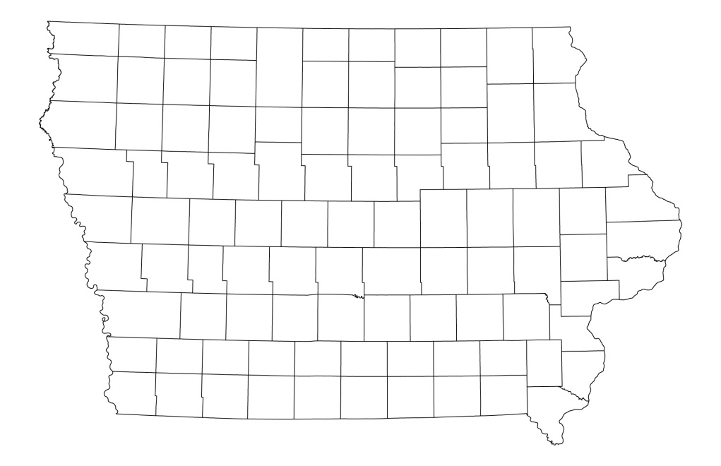

Drainage research site
Figure 1. Tile-drainage study site near Sutherland, Iowa.

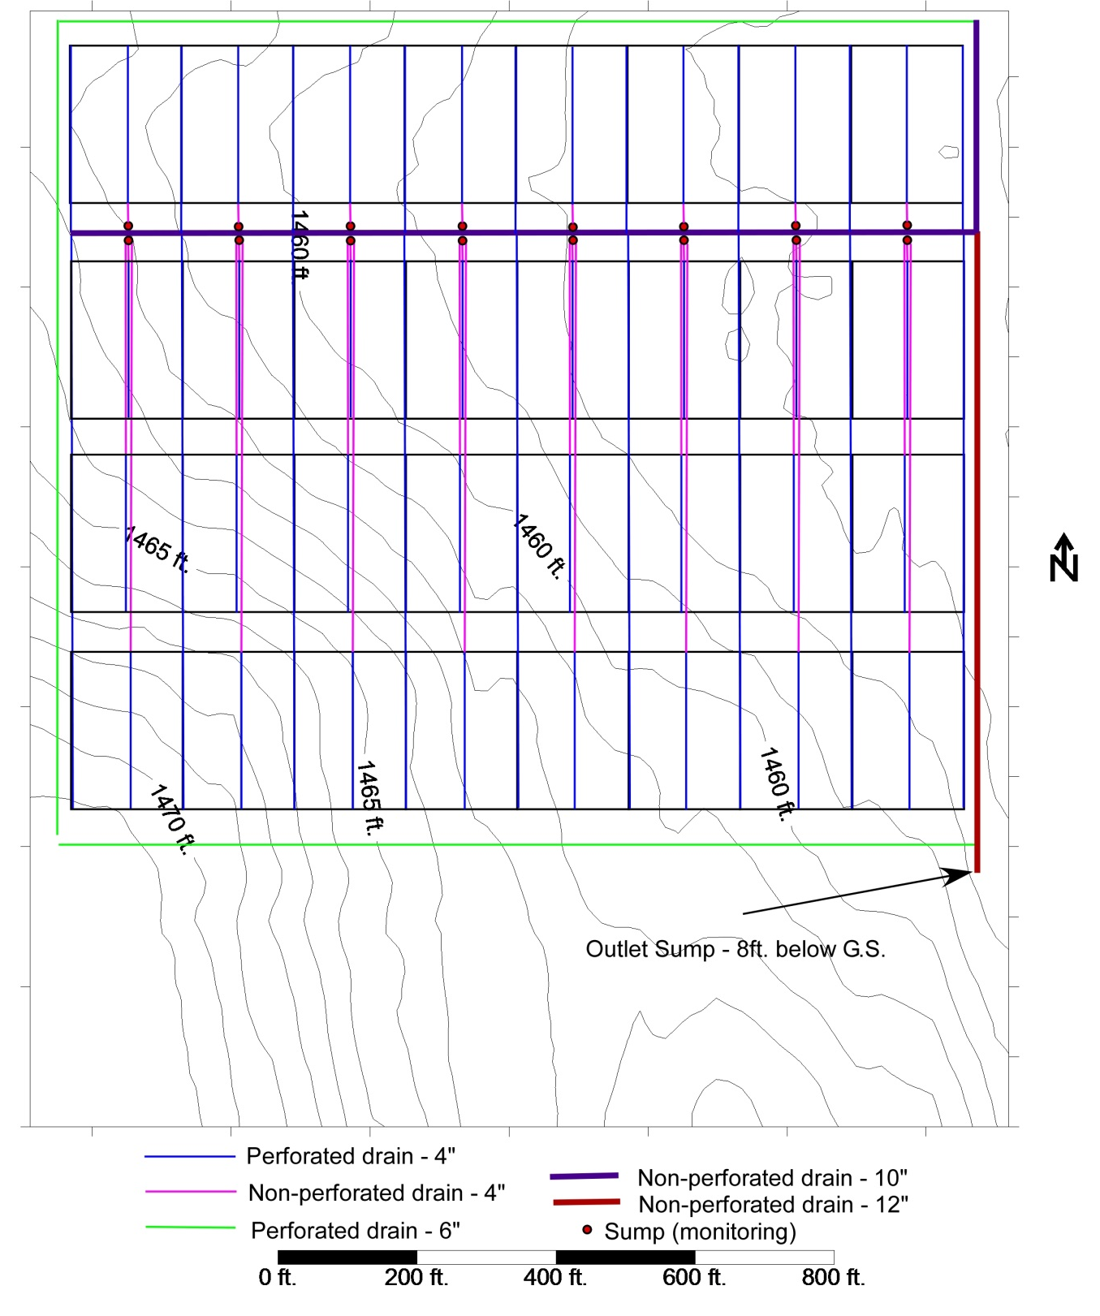
Figure 2. Subsurface overall site drainage layout, with elevation contour lines.

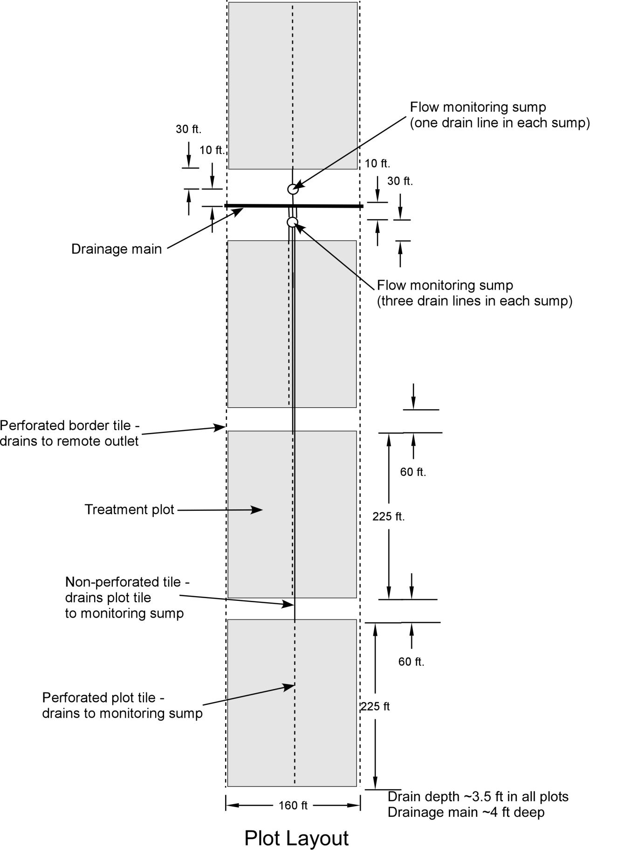
Figure 3. Subsurface drainage layout for four plots

IV. 2015-2017 Results
Except for the early fall 2014 freezing conditions which prevented fall anhydrous ammonia application (completed early spring 2015), agronomic operations were completed in a timely manner each year (Table 2). The 2015 year was characterized by greater precipitation in late summer and fall than would be normal for this geographic area and overall greater yearly precipitation than the 30-yr average precipitation (Cherokee, IA weather station which is about 10 miles south pf the project site) (Table 3). The 2016 crop year also had more than the 30-yr average precipitation, with noticeably greater precipitation in April and September. The April precipitation delayed planting in 2016. The 2017 crop year had near normal precipitation in April and May, but much less than normal precipitation for the rest of the year.
In 2015, there was a 40 bu/acre corn yield increase with N application in treatments 1-3 as compared to treatment 4 where no N was applied (Table 4). In 2016, the corn yield increase with N application was greater than 50 bu/acre. During both 2015 and 2016, no statistically significant corn yield differences were observed between the treatments where N was applied. In 2017, corn yield increase with treatments 1 and 2 compared to no N application was more than 75 bu/acre. Also, in 2017, there was a lower corn yield with the split N application compared to fall and spring ammonia timing; likely due to the limited precipitation after the sidedress N application and dry summer conditions (dry surface soil) which limited N movement into the soil and active corn root zone. There were no statistical differences among the soybean yields in 2015 which would be expected based on the uniform previous site history, no treatments applied to soybean, and no prior-year N applications to corn. Soybean yields in 2016 were greater than 70 bu/acre for all treatments and greater than 60 bu/acre in 2017. Soybean yield differences between the corn N treatments occurred in 2016 and 2017, but were inconsistent and not explainable due to N applied or not applied to corn.
There were no statistically significant differences in flow-weighted nitrate-N concentrations between treatments where soybean was grown in 2015, which would be expected due to no N treatment application in the prior year (Table 5). In the corn phase in 2015, the treatment where no N was applied had statistically lower nitrate-N concentration than all treatments where N was applied to corn. In 2016 and 2017 for the corn phase, lower nitrate-N concentration with the no N treatment did not occur as in 2015 (no significant difference between with and without N application). In 2016 for the soybean phase, the treatment where no N was applied to the 2015 corn crop had statistically significant lower nitrate-N concentration than the fall 2015 or spring 2016 N preplant applications. For all years in the corn phase, and in 2016 and 2017 in the soybean phase, the nitrate-N concentration was the same for the control and the split N application. Additional years of water quality data will provide important information in order to evaluate treatment effects over a longer time period with different weather conditions. Of note is that the drainage in 2017 was much lower than in previous years, with average drainage of about 3.5 inches compared to 10 inches in 2015 and 17 inches in 2016.
Overall, the TP and TRP concentrations in the tile flow are small, and there were no statistically significant differences in TP or TRP concentrations between treatments (Tables 6 and 7). Based on comparing concentrations of TP and TRP, it is evident most of the TP is in the TRP form.
We are continuing to summarize the crop sensing, stalk nitrate, grain N, and soil nitrate-N data collected in 2015, 2016, and 2017.

Project Dissemination
- June 15, 2016 – Presentation on “Nitrate reduction of 4R nitrogen management” at 4R Summit in Indianapolis, IN
- July 13, 2016 – Presentation on “Practices for nitrate-N reduction” at Northwest Research and Demonstration Farm Summer Field Day near Sutherland, IA (75 attendees)
- June 13, 2017 – Presentation on “Impacts of 4R Nitrogen Management on Drainage Water Quality” at 4R Summit in Minneapolis, MN (125 attendees)
- June 27, 2017 – Presentation on “Drainage Water Quality studies at Iowa State University” as part of N week in Ames, IA (35 attendees)
- June 29, 2017 – Presentation on “Drainage Water Quality studies at Iowa State University” as part of N week in Crawfordsville, IA (35 attendees)
- November 1, 2017 – Presentation on “Drainage Water Quality studies at Iowa State University” as part of 4R Plus meeting in Des Moines, IA (35 attendees)
- November 29, 2017 – Presentation on “Impacts of 4R Nitrogen Management on drainage water quality” at Integrated Crop Management Conference in Ames, IA (225 attendees)
- December 13, 2017 – Presentation on “Impacts of 4R Nitrogen Management on Drainage Water Quality” at the South Dakota Agronomy Conference (200 attendees)

Table 2. Dates of field operations for corn.
 | 2015 | 2016 | 2017
Fall anhydrous ammonia application (with inhibitor) | April-18 | November 10 2015 | November-16, 2016
Spring anhydrous ammonia application | April-18 | April-18 | April-17
Planting date | May-18 | May-18 | May-17
Urea starter banded with planter | May-18 | May-18 | May-17
Agrotain treated urea dribbled sidedress | July-18 | July-18 | July-17
Corn harvest | October-18 | October-18 | October-17
Sulfur application |  | November-3 (15.6 lbs of sulfur/acre as Gypsum)
Planting population (seeds/acre) | 34,000 | 34,000 | 35,077
Corn hybrid | Pioneer P0453 | AgriGold 6267VT2RIB | Pioneer P0157AMX

Table 3. Monthly precipitation and drainage in 2015, 2016, and 2107.
Mon | Precipitation (in) |  |  | 30-yr Avg. Precip. at Cherokee, IA (in) | Average Drain Flow (in)
 |  |  |  |  | 2015 |  | 2016 |  | 2017
 | 2015 | 2016 | 2017 |  | Corn | Soybean | Corn | Soybean | Corn | Soybean
Jan | 0.1 | 0.2 | 1.0 | 0.6 | . | . | . | . | . | .
Feb | 0 | 0.4 | 0.8 | 0.6 | . | . | . | . | . | .
Mar | 0.6 | 2.1 | 1.4 | 1.9 | . | . | 0.7 | 1.4 | 0.6 | 0.4
Apr | 3.1 | 5.2 | 3.2 | 3.1 | 0.8 | 0.9 | 4.3 | 5.6 | 0.6 | 0.4
May | 3.5 | 3.5 | 3.0 | 3.9 | 0.9 | 0.5 | 2.8 | 4 | 2.6 | 2.4
Jun | 2.6 | 1.8 | 1.9 | 5 | 0.2 | 0 | 0 | 0.1 | 0.0 | 0.0
Jul | 6.8 | 3.9 | 1.3 | 3.9 | 0.2 | 0.1 | 0.1 | 0.6 | 0.0 | 0.0
Aug | 6.1 | 3.2 | 4.3 | 3.7 | 0.7 | 0.2 | 0 | 0 | 0.0 | 0.0
Sep | 2.8 | 7.5 | 2.3 | 3.5 | 0.5 | 0.2 | 5.2 | 5.6 | 0.0 | 0.0
Oct | 1.9 | 3.5 | 3.3 | 2.1 | 0.3 | 0 | 1.2 | 2 | 0.0 | 0.0
Nov | 4.9 | 1.8 | 0.2 | 1.5 | 4.6 | 4.3 | 0.3 | 0.7 | 0.0 | 0.0
Dec | 1.8 | 1 | 0.2 | 0.9 | 3.6 | 2.8 | 0 | 0.1 | 0.0 | 0.0
Total | 34.1 | 34 | 22.9 | 30.7 | 11.8 | 9 | 14.6 | 20.2 | 3.9 | 3.2

Table 4. Crop yields for 2015, 2016, and 2017 (bu/acre).
Trt | N Management for Corn | Corn |  |  |  |  |  | Soybean
 |  | 2015 |  | 2016 |  | 2017 |  | 2015 |  | 2016 |  | 2017
1 | Fall anhydrous ammonia (with inhibitor) | 221 | a* | 198 | a | 203 | a | 62 | a | 74 | ab | 62 | b
2 | Spring anhydrous ammonia | 223 | a | 200 | a | 203 | a | 64 | a | 75 | a | 67 | a
3 | Split N | 224 | a | 196 | a | 181 | b | 64 | a | 72 | b | 66 | a
4 | None | 183 | b | 141 | b | 125 | c | 61 | a | 74 | ab | 64 | ab
*Means with the same letter in the same column are not significantly different, P=0.05. Yields reported at 15.5% moisture for corn and 13% for soybean.

Table 5. Flow-weighted nitrate-N concentrations (mg N/L).
Trt | N Management for Corn | 2015 |  |  |  | 2016 |  |  |  | 2017
 |  | Corn |  | Soybean |  | Corn |  | Soybean |  | Corn |  | Soybean
1 | Fall anhydrous ammonia (with inhibitor) | 16.2 | a* | 12.7 | a | 12.7 | a | 13.2 | a | 13.2 | a | 8.9 | ab
2 | Spring anhydrous ammonia | 15.7 | a | 13.4 | a | 12.1 | a | 13.7 | a | 13.8 | a | 12.2 | a
3 | Split N | 12.0 | ab | 12.1 | a | 10.1 | a | 11.1 | ab | 9.7 | a | 8.6 | ab
4 | None | 9.1 | b | 12.5 | a | 9.7 | a | 7.6 | b | 11.8 | a | 5.7 | b
*Means with the same letter in the same column are not significantly different, P=0.05.

Table 6. Flow-weighted total P (TP) concentrations (mg P/L).
 |  | 2015 |  |  |  | 2016
Trt | N Management for Corn | Corn |  | Soybean |  | Corn |  | Soybean
1 | Fall anhydrous ammonia (with inhibitor) | 0.022 | a* | 0.020 | a | 0.020 | a | 0.016 | a
2 | Spring anhydrous ammonia | 0.026 | a | 0.019 | a | 0.018 | a | 0.021 | a
3 | Split N | 0.022 | a | 0.019 | a | 0.019 | a | 0.016 | a
4 | None | 0.020 | a | 0.020 | a | 0.017 | a | 0.014 | a
*Means with the same letter in the same column are not significantly different, P=0.05.
Note: Total P not analyzed in 2017.

Table 7. Flow-weighted total reactive P (TRP) concentrations (mg P/L) for 2015-2017.
 |  | 2015 |  |  |  | 2016 |  |  |  | 2017
Trt | N Management for Corn | Corn |  | Soybean |  | Corn |  | Soybean |  | Corn |  | Soybean
1 | Fall anhydrous ammonia (with inhibitor) | 0.022 | a* | 0.017 | a | 0.019 | a | 0.017 | a | 0.017 | a | 0.029 | a
2 | Spring anhydrous ammonia | 0.024 | a | 0.020 | a | 0.017 | a | 0.020 | a | 0.021 | a | 0.018 | b
3 | Split N | 0.026 | a | 0.019 | a | 0.019 | a | 0.016 | a | 0.023 | a | 0.021 | ab
4 | None | 0.021 | a | 0.020 | a | 0.017 | a | 0.014 | a | 0.020 | a | 0.019 | b
*Means with the same letter in the same column are not significantly different, P=0.05.

References
Baker, J.L., M.B. David, D.W. Lemke, and D.B. Jaynes. 2008. Understanding nutrient fate and transport. pp. 1-17 in Gulf Hypoxia and Local Water Quality Concerns Workshop, ASABE Pub #913C0308.
Crumpton, W.G., T.M. Isenhart, and P.D. Mitchell. 1992. Nitrate and organic N analyses with second-derivative spectroscopy. Limnology and Oceanography, 37:907-913.
Dale, V.H., C. Kling, J.L. Meyer, J. Sanders, H. Stallworth, T. Armitage, D. Wangsness, T.S. Bianchi, A. Blumberg, W. Boynton, D.J. Conley, W. Crumpton, M.B. David, D. Gilbert, R.W. Howarth, R. Lowrance, K. Mankin, J. Opaluch, H. Paerl, K. Reckhow, A.N. Sharpley, T.W. Simpson, C. Snyder, D. Wright. 2010. Hypoxia in the Northern Gulf of Mexico. Springer, New York, 284 pages.
David, M.B., L.E. Gentry, D.A. Kovacic, and K.M. Smith. 1997. Nitrogen balance in and export from an agricultural watershed. J. Environ. Qual. 26:1038–1048. doi:10.2134/jeq1997.00472425002600040015x.
Keeney, D.R., and T.H. DeLuca. 1993. Des Moines river nitrate in relation to watershed agricultural practices: 1945 versus 1980’s. J. Environ. Qual. 22:267–272. doi:10.2134/jeq1993.00472425002200020006x.
Lawlor, P. A., M.J. Helmers, J. L. Baker, S. W. Melvin, and D. W. Lemke. 2008. Nitrogen
application rate effects on nitrate-nitrogen concentrations and losses in subsurface drainage. Trans. ASABE 51(1): 83-94.
Lowrance, R. 1992. Nitrogen outputs from a field-size agricultural watershed. J. Environ. Qual. 21:602–607. doi:10.2134/jeq1992.00472425002100040013x.
Murphy, J and J. Riley, 1962. A modified single solution method for the determination of phosphate in natural waters. Anal. Chem. Acta. Vol. 27 page 31.
Rabalais, N.N., R.E. Turner, and W.J. Wiseman, Jr. 2001. Hypoxia in the Gulf of Mexico. J. Environ. Qual. 30:320–329. Doi: 10.2134/ jeq2001.302320x.
Zucker, L.A., and L.C. Brown. 1998. Agricultural drainage: Water quality impacts and subsurface drainage studies in the Midwest. Ohio State Univ. Ext. Bull. 871. The Ohio State University, Columbus.

