**Annual Progress Report submitted to IPNI and Foundation for Agronomic Research (FAR)**

**Project: Can application of enhanced efficiency fertilizers at planting reduce N losses from grain corn production in Ontario? (FAR identifier CAN-4RC01)**

**Project leader and contact information:**

Claudia Wagner-Riddle, School of Environmental Sciences, University of Guelph, [cwagnerr@uoguelph.ca](mailto:cwagnerr@uoguelph.ca), phone: 519-824-4120 ext. 52787.

**Project Purpose:** The overall goal of this project is to determine how combination of Right Time and Right Source of inorganic nitrogen fertilizer application to corn affect nitrogen losses in the form of nitrogen leaching and nitrous oxide fluxes.

**Treatments:** An experiment was set up in April 2015 (year 1 of 3 years) with the following plots:

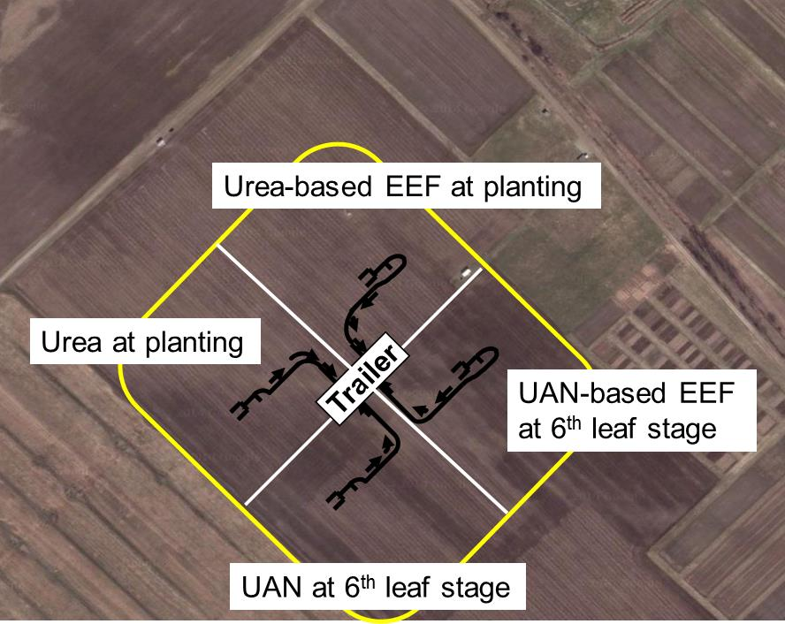

**Objectives:** Our objectives are the following:

1) to evaluate if applying the Right Product at planting (Enhanced Efficiency fertilizer with nitrification and urease inhibitors NUI to urea, Urea + NUI) or at side-dress (UAN + NUI) reduces nitrous oxide emissions and leaching losses compared to just urea or UAN, respectively;

2) to establish if applying at the Right Time (UAN at side-dress) reduces nitrous oxide emissions and leaching losses compared to urea at planting;

3) to verify if applying the Right Product at the Right Time (UAN+NUI applied as side-dress around 6th leaf stage) reduces nitrous oxide emissions and leaching losses compared to urea.

**Methods:** We are using a micrometeorological method to measure half-hourly N2O fluxes over four plots in sequence for a maximum of 12 observations per plot per day. Air is continuously sampled from two heights over each plot and directed through a tunable diode laser trace gas analyzer. These measurements combined with turbulence characterization of the air give us the amount of gas (nitrous oxide and carbon dioxide; greenhouse gases) emitted per area. Measurements of N2O fluxes started in May 2015. Soil solution samples from 80 cm depth were installed in fall 2015 and were combined with an estimate of deep drainage inferred from changes in soil storage (assessed with profile measurements of soil water content) and evapotranspiration (measured with an eddy covariance system) to give amount of nitrogen leached over a year. Supporting data includes plant biomass and yield, and soil mineral nitrogen content. The following pictures show field activities during the growing season of 2016.

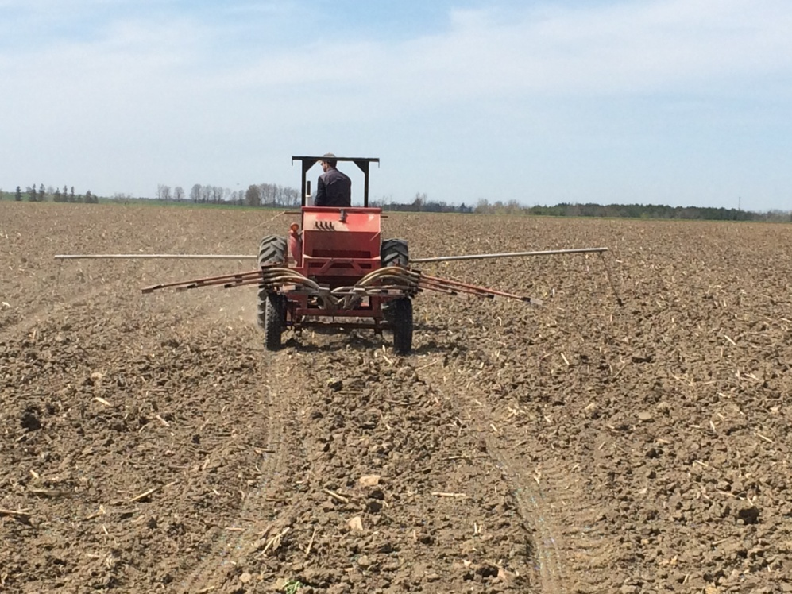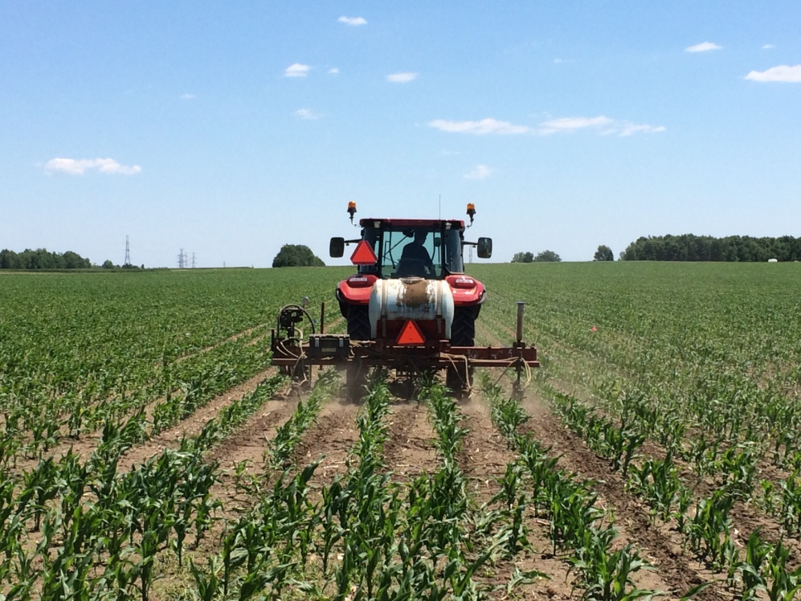

**Overview of Year 1 and 2 Results:**

Anaerobic events at 5 cm occurred after both planting and side-dress fertilization in 2015. In 2016 the soil was drier and anaerobic condition at 5 cm were not observed between planting and silking stage (Figure 1). Consequently, no significant emission events occurred in 2016, but high emission events were frequent in 2015, when nitrate concentration in soil was high and after precipitation events leading to WFPS values higher than 60% (Figures 2).

For the weather conditions experienced in the 2015 corn growing season, significantly less N2O emission happened for the field receiving UAN + NUI compared to the field fertilized with UAN at side-dress stage, with no source effect observed at planting. Timing did not affect N2O emissions (Figure 3). Due to the dry soil conditions, significantly less emissions were observed in 2016 than in 2015 (Figures 3). For 2016, applying urea + NUI at planting resulted in less N2O emissions than just urea applied at planting, UAN + NUI at the side-dress stage resulted in less emission than urea applied at planting (Figure 3).

Drainage events occurred during winter and early spring (Nov. to April) (Fig. 3A), and NO­3‑-N concentration was highest during winter (Nov. to Feb.) (Fig. 3B). Winter freeze-thaw cycles may have induced several NO3--N leaching events (Fig. 3C).

Urea with NUI at planting did not have a significant effect on NO­3‑-N leaching compared to Urea (Fig. 4), however, UAN with NUI at side-dress stage had a significant effect on NO­3‑-N leaching compared to UAN with now inhibitors (Fig. 4). Applying regular UAN product at side-dress stage had a significant effect on NO­3‑-N leaching, with a further reduction obtained by applying an EEF product (Fig. 4). Measurements are on-going and will continue until May 2017.

Corn yield showed significant reduction due to the delay in applying UAN as side-dress in 2015, although this effect was not observed for UAN+NUI (Figure 4). No significant differences were observed in 2016 (Figure 6).



**Figure 1: Precipitation (solid blue bars); and, soil water filled pore space - WFPS at 5 cm (solid line) and 25 cm (dashed line). The black and gray areas indicate anaerobic conditions at 5 and 25 cm, respectively.**



**

**

**Figure 2: N2O flux (solid gray line with solid circles); soil nitrate at 0-15 cm (dash dot line and dark circles); and, soil nitrate at 15-30 cm (dashed line and open triangles).**



**Figure 3: Cumulative emissions and statistical analysis. Wilcoxon signed-rank test with a Bonferroni correction was performed as a post hoc test. **= p<0.01.**



**Figure 4. Weekly averages: A. water budget components. B. NO3--N concentration (with SEM). C. NO3--N leached. Arrow indicates fertilization.**



**Figure 5. Comparison of NO3--N leached for treatments with application at planting (urea and urea+NUI) and application at sideress (UAN and UAN+NUI from Nov. 2015 to July 2016. Significant differences determined using a t-test (P ≤ 0.05).**



**Figure 6: Corn grain yield measured in 2015 and 2016 for the timing and N source treatments.**

**SUMMARY TABLE:**

|  |  |  |
| --- | --- | --- |
| **4R** | **Description** | **Preliminary Result** |
| Right Product at planting | Urea-based EEF vs. Urea at corn planting | Significant N2O effects observed in dry year only when emissions were very small |
| Right Time | UAN at 6th leaf stage vs. urea at planting | Benefits for Right Time were not observed in either of the years studied |
| Right Product at 6th leaf stage | UAN-based EEF vs. UAN at 6th leaf stage | A significant reduction in N2O emissions and NO3 loss were observed with the Right Product in the wet year when emissions were large |
| Right Product and Right time | UAN-based EEF at 6th leaf stage vs. urea at planting | A significant reduction was observed for right product at side-dress only in the dry year when emissions were small |