**Annual Report**

**Evaluating the 4R Nutrient Stewardship Concept and Certification Program in the Western Lake Erie Basin**

**Submitted by**

**Kevin King**

**1/19/2016**

**Interpretive Summary:** Since the mid 1990s, soluble phosphorus (P) entering Lake Erie has steadily increased, promoting nuisance and harmful algal blooms (HABs). The focus of this excess P delivery has been on agriculture. The 4R principles of nutrient stewardship have been promoted in the WLEB and adoption is gaining momentum with more than 1,000,000 acres within the Western Basin being managed by a 4R certified retailer/service provider. However, understanding and quantifying the water quality benefits of the 4R program need to be accomplished. A multifaceted research project was initiated in July 2014 to quantify the edge-of-field and watershed scale effects of the 4R program. The project includes: data collection from edge-of-field and watershed scales; watershed and in-lake modeling; a socioeconomic assessment of producers; a triple bottom line assessment of the 4R program including a survey of retailers; and education and outreach. Site selection and instrumentation of the edge-of-field sites was completed and data collection has begun. Watershed water quality data collection through the National Center for Water Quality Research is ongoing. SWAT models for three major watersheds that comprise the WLEB have been populated and different scenarios are being projected to assess the effects of the 4R program. Previous producer and retailer surveys have been evaluated. A second producer survey has been developed and has recently been mailed. Additionally, outreach and promotion of the 4R program have occurred at multiple meetings and venues.

**Objective 1: To monitor the impacts of 4R Nutrient Stewardship practices and the 4R Certification Program on crop productivity, nutrient losses, and biotic integrity from select fields, streams, and watersheds in the WLEB.**

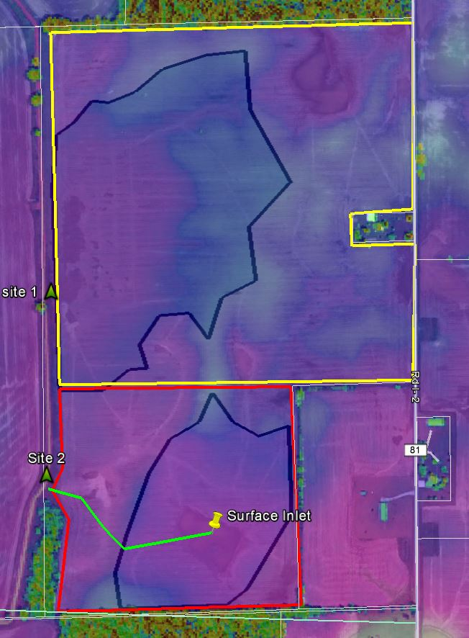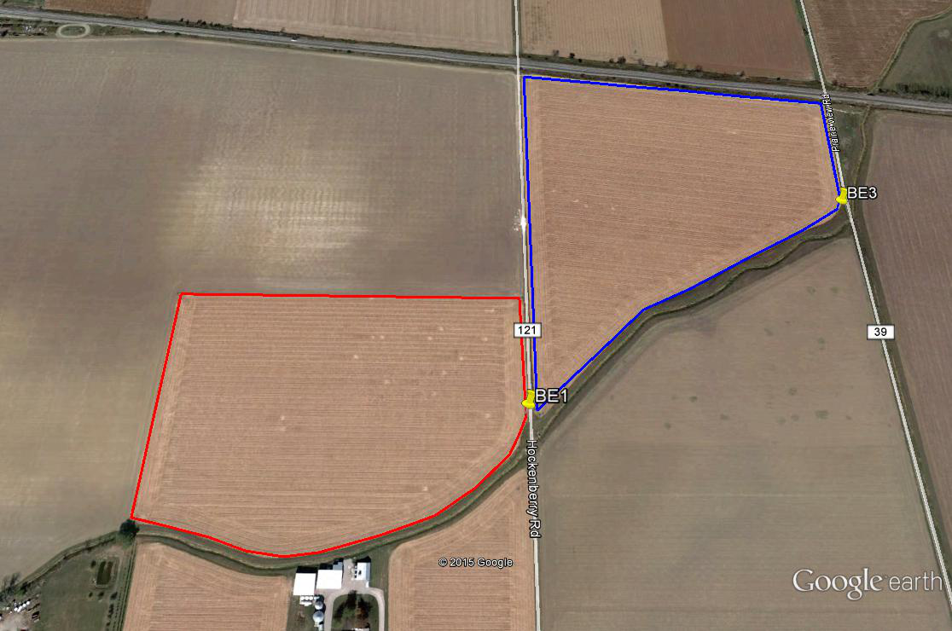

**C**

**A**

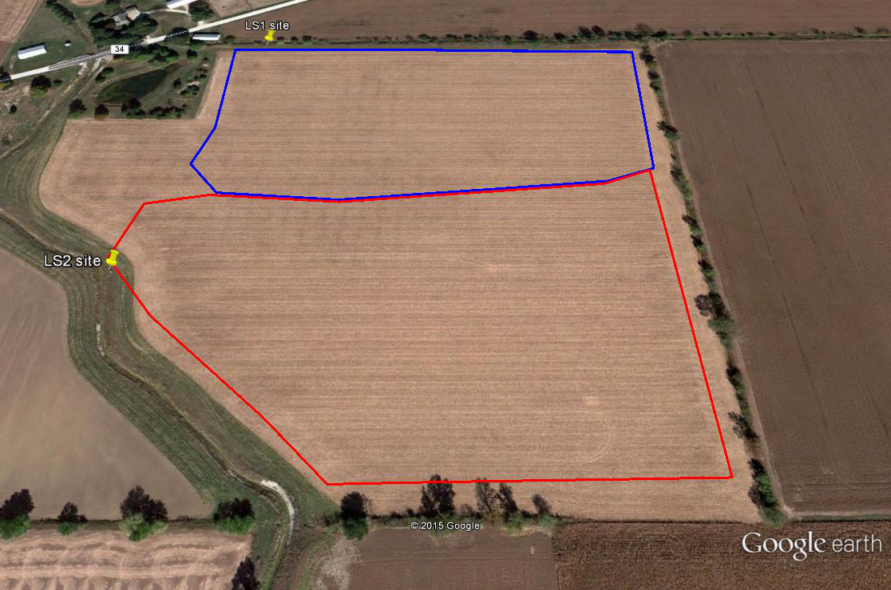

**B**

**Figure 1. Outline of fields in Ohio (A&B) and Indiana (C) to be used for edge-of-field monitoring to support the 4R Research Project.**

***Edge-of-Field (EOF) Monitoring:*** Two sites in Ohio and one in Indiana were identified for combined surface and subsurface EOF monitoring (Figure 1A, 1B, and 1C). The Ohio sites are located in Wood County in the Portage River Watershed. The Indiana site is located in Steuben County on the Ohio-Indiana border. All three sites are representative of crop production agricultural systems in the tile drained landscape of the WLEB. Instrumentation was completed at the Ohio sites in Jan/Feb 2015 and the Indiana site in Nov/Dec 2015.

Data collection from the Ohio sites has been ongoing since completion of data installation (Figure 3). The BE site had wheat in 2015 while the LS site was planted to corn in 2015. Management data from the sites is being collected and compiled at this time. At the Indiana site, flow has not occurred through the H-flume yet. Field is still rough from September intensive tiling operation. Farmer has disked it down somewhat, will probably disk again in the spring prior to planting (Figure 5). At the Indiana site, we are currently having power issues which are wreaking havoc with the samplers. Voltage limitations within the signature system have basically disabled the sites due to the lack of sunlight for battery regeneration. We are in the process of getting some additional power transformers that hopefully will reduce significantly the power issues by either raising or lowering the voltage as needed to maintain 13.4V.

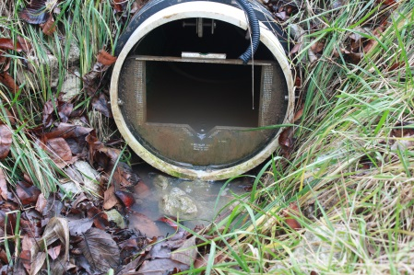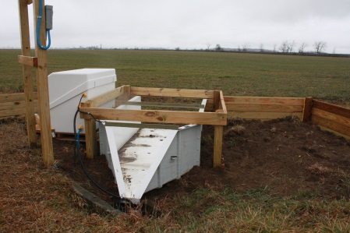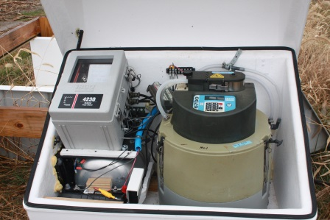

**Figure 2. Example of EOF monitoring equipment in Ohio (photos by Tom Bruulsema).**



**Figure 3. Preliminary EOF data from BE site in Ohio.**

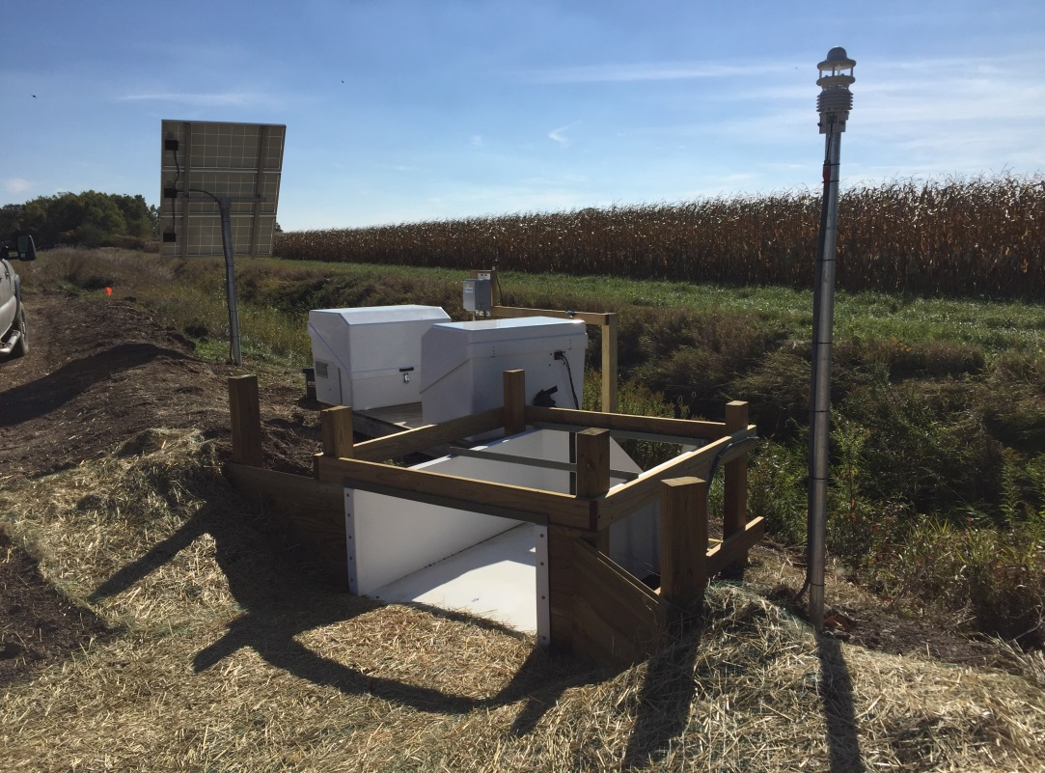

**Figure 4. H-flume from Indiana site.**

**Manuscripts and presentations by Kevin King and Mark Williams related to EOF component:**

* + - 1. King, K.W., M.R. Williams, and N.R. Fausey. Effect of crop type and season on nutrient leaching to tile drains under a corn-soybean rotation. J. Soil and Water Conservation 71:56-68. 2016.
      2. Williams, M.R., K.W. King, W.I. Ford, and N.R. Fausey. Edge-of-field research to quantify the impacts of agricultural practices on water quality in Ohio. J. Soil and Water Conservation 71:9A-12A. 2016.
      3. Williams, M.R., K.W. King, W.I. Ford, A.R. Buda, and C.D. Kennedy. Effect of tillage on macropore flow and phosphorus transport to tile drains. Water Resources Research (revisions submitted in November 2015).

1. February 18 –“Effect of agricultural management on surface and subsurface nutrient transport” at the Certified Livestock Manager (CLM) Training meeting, ODA (Reynoldsburg, OH)
2. February 19 – “Surface and subsurface nutrient loss from edge-of-field sites in Ohio” to the Maumee/WLEB CEAP working group, Lake Erie Center (Oregon, OH)
3. February 26 – “Nutrient loss in surface and subsurface drainage: preliminary results from edge-of-field studies” at the Agronomy Workshop and Expo and Fertilizer Certification training meeting (Waldo, OH)
4. March 4 – “Using paired watershed data to assess impacts of agricultural production and best management practices” at the Conservation Tillage and Technology Conference (CTTC), Ohio Northern Univ. (Ada, OH)
5. March 9 - “Edge of field research on P: paired watershed data” at the All Ohio Chapter SWCS, ODA (Reynoldsburg, OH)
6. May 12- “Evaluating the 4R concept and certification program in the WLEB” at 4R Summit in Washington, DC.
7. May 13 – a congressional briefing on 4R research in WLEB (Washington, DC).
8. Jun 26 – “Edge of Field Research: Surface and Subsurface P Movement” to Ohio P Task Force (Columbus, OH)
9. July 24 – Provided a briefing to Senator Portman on “Helping producers evaluate water quality impacts of agricultural practices” (Oak Harbor, OH)
10. July 28 – “Surface and Subsurface P Transport in Tile Drained Landscapes” at ASABE meeting (New Orleans, LA)
11. July 30 – Provided presentation “Evaluation of BMPs for addressing P transport in tile” at a TNC field day (Fulton County, OH)
12. Aug 12-“Edge-of-field P losses: edge-of-field findings and potential mitigation practices” at OSU Manure Science Day, Union City, OH
13. Aug 13-“Edge-of-field P losses: edge-of-field findings and potential mitigation practices” and field tour at NRCS State Technical Committee Mtg (Celina, OH)
14. Aug 18-“P loss in tile drainage” at WLEB working group meeting (Oregon, OH)
15. Aug 20- “Edge-of-field Phosphorus: Management and Mitigation Impacts” at Managing our Water; The Field and Beyond conference (Oregon, OH)
16. Aug 25 – “Edge-of-field water quality studies in Ohio” to Conservation Action Project board and members (Napoleon, OH)
17. Aug 28- “Edge-of-field research: collaborations, partnerships, and outreach” at Ag Water Quality Monitoring Forum: Advancing Indiana’s Nutrient Management and Soil Health Strategy (Indianapolis, IN)
18. Sep 2 – “Edge-of-field P losses: edge-of-field findings and potential mitigation practices” at TNC sponsored Western Lake Erie Basin: Nutrient Stewardship in Action mtg. (Oregon, OH)
19. Sep 16 – “Edge-of-field research findings and best management practices” at Crawford County Field Day (Bucyrus, OH)
20. Sep 18 – “Edge-of-field research findings and best management practices” at Hardin County Field Day (Dunkirk, OH)
21. Sep 21 – “Edge-of-field research: tile drainage and phosphorus” at Seneca County conservation meeting (Tiffin, OH)
22. Oct 6 – “Agricultural Phosphorus Losses: What is edge-of-field data telling us?” to Michigan Farm Bureau (remote by webex)
23. Oct 15 – “Practices to address edge-of-field P losses in Lake Erie Basin” to Western Lake Erie Basin working group (Oregon, OH)
24. Oct 16 – “Agricultural Phosphorus Losses: What is edge-of-field data telling us?” and tour of edge-of-field sites for Ohio congressmen and staffs (Wood County, OH)
25. Nov 19 – “Using paired edge-of-field data to assess impacts of management on surface and subsurface P loss” to SERA-17 (Minneapolis, MN)
26. Dec 1 – “Monitoring surface runoff and tile drainage using automated and passive sampling” at Healthy Soils for Healthy Waters and Edge-of-Field Monitoring Workshop in Memphis, TN
27. Dec 1 – “Drainage Water Management” at Healthy Soils for Healthy Waters and Edge-of-Field Monitoring Workshop in Memphis, TN
28. Dec 2 – “What We Monitor For and What We Learn at Different Monitoring Scales” at Healthy Soils for Healthy Waters and Edge-of-Field Monitoring Workshop in Memphis, TN
29. Dec 3 – “Edge-of-Field Water Quality Monitoring: The First Step in Agricultural Practice Assessment in the Field to Lake Continuum” at Healthy Soils for Healthy Waters and Edge-of-Field Monitoring Workshop in Memphis, TN
30. Dec 15 – “Using stable isotope tracers to assess flow pathways for P transport in tile-drained landscapes” at AGU Fall Meeting (San Francisco, CA)

***Watershed Monitoring and Biotic Measurements:***

* Purchased YSI EXO2 multiparameter sondes, light sensors, and Minidot oxygen sensors. All sensors were tested for sampling frequency and battery life and then calibrated for biotic measurements.
* YSI sondes and light sensors were deployed at the Heidelberg Tributary Loading Program (HTLP) sites on the Sandusky River at Fremont and on the Portage River at Woodville in May 2015. Sondes have been in place continuously, except during calibration and data download periods.
* Minidots (Figure 5) were deployed at an edge-of-field pair in Wood County (Portage River watershed) for the month of August 2015. Field methods for reaeration measurements were tested during this time as well.
* The 2015 water year data collection was recently updated for all HTLP watersheds, including those data used in this project. Data are available for download at <http://www.heidelberg.edu/academiclife/distinctive/ncwqr/data/data>
* Met with Kevin King and Mark Williams in October 2015 to discuss collaborations, including a paper using our combined datasets to show the importance of the 4Rs.

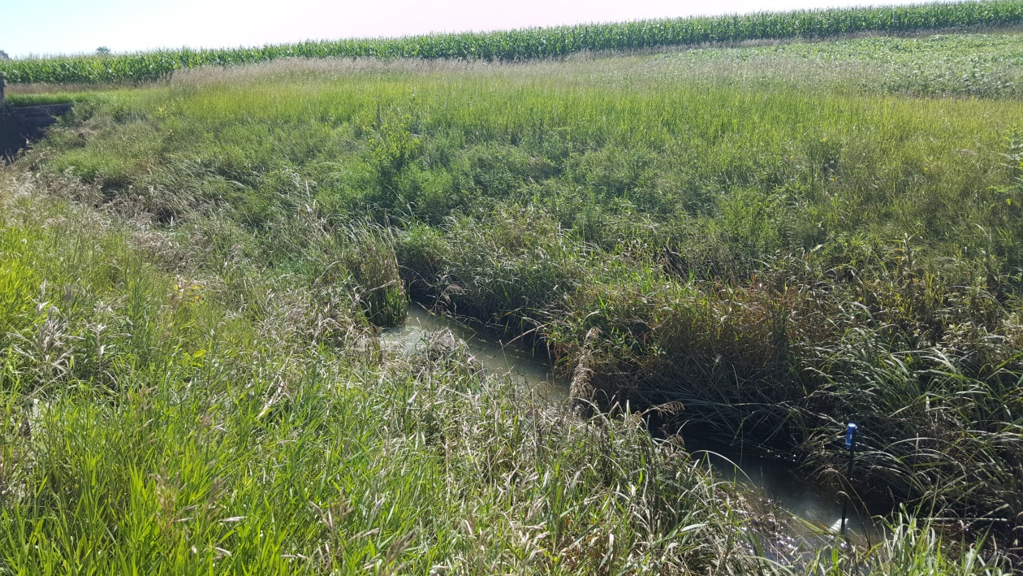

**Figure 5. Minidot deployed in drainage ditch at EOF site.**

**Presentations related to watershed and biotic component presented by Laura Johnson where the 4Rs were discussed and/or the 4R research project was credited.**

1. July 2015: Weak links in communication contribute to harmful algal blooms in Lake Erie. 70th Annual Soil and Water Conservation Society Conference. Greensboro, NC.
2. 25 July 2015: Lake Erie algae: causes and solutions. Farmer tour and presentation at the NCWQR. Tiffin, Ohio
3. 23 April 2015: Nutrient Loading to Lake Erie. Northeast Section of the Ohio Water Environment Association (OWEA). Richfield, Ohio
4. 2 March 2015: Agricultural runoff and Lake Erie: Past, present, and future. Iowa Water Conference Plenary. Ames, Iowa (webinar due to weather).
5. 28 February 2015: Lake Erie algae: causes and solutions. Farmer tour and presentation at the NCWQR. Tiffin, Ohio
6. 8 January 2015. Lake Erie re-eutrophication: Where is the phosphorus coming from? EPA-NRCS-SERA17 Information Exchange Webinar.
7. 12 January 2015. Practical causes of harmful algal blooms in Lake Erie. Michigan Agri-Business Association Winter Conference. Lansing, Michigan.
8. 22 January 2015. Lake Erie Western Basin Phosphorus Sources. Lake Erie Sources and Solutions workshop hosted by TMACOG (Toledo Metropolitan Area Council of Governments). Toledo, Ohio
9. 3 February 2015. Practices to reduce dissolved phosphorus runoff. Natural & Environmental Resources Advisory Committee of the Michigan Farm Bureau. Lansing, Michigan (webinar).

**Objective 2: To model the environmental benefits in Lake Erie (turbidity and HABs) following various levels of implementation of 4R Nutrient Stewardship practices and the 4R Certification Program in three WLEB agricultural watersheds.**

***Maumee River Basin SWAT and WLEEM Model (LimnoTech: Todd Redder and Joe Depinto):***

**General Notes**:

* SWAT model development, calibration, and application activities have also been supported by a grant provided by the Erb Family Foundation.
* “Western Lake Erie Ecosystem Model” (WLEEM) development, calibration, and application activities have been co-supported by several other projects funded by NSF, CSMI, and USEPA.

**Soil & Water Assessment Tool (SWAT) – Maumee River Basin**

**Model framework enhancements:**

* Enhanced representation of tile drainage processes related to nutrient transport in SWAT 2012.
* Incorporated additional diagnostic output options into SWAT 2012 and developed tools for visualizing model output (e.g., slide 5 in Attachment 2).

**Model development & calibration:**

* Model simulation period extended from 1995-2005 (original timeframe) to 1995-2014 in order to capture extreme high/low Maumee flow in years 2011/2012 and to take advantage of Heidelberg University daily nutrient loading data available for the Tiffin River (Stryker, OH) and the Blanchard River (Findlay, OH) beginning in summer 2007.
* Model calibrated to 1995-2010 period based on data available from the following sources:
* Multiple USGS flow gages, including Waterville, OH gage and at least one gage for each major tributary to the Maumee River (i.e., St. Joseph, St. Marys, Tiffin, Auglaize).
* Hydrology calibration: key statistics and plots shown on slides 10-13 in Attachment 2.
* Water quality calibration: key statistics and plots shown on slides 15-18 in Attachment 2.
* Simulated crop yields shown in slide 19 in Attachment 2.

**Application to BMP scenarios:**

* Applied model to suite of Maumee basin-wide “extreme” BMP scenarios, including multiple 4R-related scenarios, based on 2000-2014 climate conditions.
* “Extreme” scenario descriptions are provided on slide 22 in Attachment 2. (Note that scenarios 1-4 and 6 are relevant to 4R and drainage management, respectively.)
* Example results from scenario simulations provided on slides 23-28 in Attachment 2.
* Applied model to a set of more realistic “bundled” scenarios :
* Scenarios developed in coordination with WLEB stakeholders with the intent of identifying (random or targeted) BMP implementation that could achieve the necessary phosphorus load reductions established through the Lake Erie Annex 4 process.
* Description of bundled scenarios provided in Attachment 3.

***Western Lake Erie Ecosystem Model (WLEEM)***

* Model development & calibration:
* Calibrated WLEEM model to Western Lake Erie nutrient concentration data and blue-green (Microsystis) biomass data available for 2008, 2011, 2012, 2013, and 2014.
* Model application:
* Simulated loading reductions of 0% (baseline), 25%, 50%, and 75% for Maumee River total phosphorus load and used results to develop a load-response curve relating harmful algal bloom (HAB) biomass to “spring” (March-July) total phosphorus loading from the Maumee River.
* Conducted forecasting with model to project harmful algal bloom (HAB) extent and severity for summer 2015.
* *Preliminary* model calibration results and HAB-load response curve results are provided in Attachment 4.
* WLEEM Manuscript will be submitted in January 2015 for publication in a special issue of the Journal of Great Lakes Research focused on Annex 4 modeling efforts for Lake Erie.

**Attachments:**

1. Redder et al. 2015. “Maumee Basin SWAT Modeling.” Presentation given at Western Lake Erie Basin Scenario Workshop , Ann Arbor, MI, June 22-23.

***(Note: Calibration statistics provided in Attachment 1 are superseded by calibration results shown in Attachment 2.)***

1. Boles et al. 2015. “Use of a calibrated SWAT model to support (BMP) evaluations in the Maumee River watershed.” Presentation given at 2015 SWAT Workshop held at Purdue University, West Lafayette, IN, October 12-16.
2. Description of bundled scenarios for Maumee multi-model comparison (12/18/15).
3. DePinto et al. 2015. “WLEEM Load-Response Application to the Western Basin of Lake Erie.” Presentation given at 2015 International Association for Great Lakes Research (IAGLR) conference.

***Sandusky and Cedar-Portage watershed (Rem Confesor):***

The updated management schedule includes the split of nitrogen fertilizer application in spring and addition of Corn-Soybean double crop application of fertilizer. Both the Sandusky and Portage models are being updated to the 2009-2014 crop season. This process also involves updating the temperature and precipitation data. NEXRAD precipitation at 4 km grid has been processed and is being compared with observed precipitation data from NOAA's Climate Data Center. Final model setup will be done in June 2016 and calibration will start thereafter.

Presentations related to and funded in part by the project:

1. Reducing Nutrient Loading: Are We Targeting the Right Sources and Implementing the Right Solution? Oral presentation at International Association of Great Lakes Research Annual Conference, May 2015.

2. Shooting A Moving Target: A Dissolved Phosphorus Problem Paradigm. Oral presentation at Soil and Water Conservation Society Annual Conference, July 2015.

3. Targeting Critical Source Areas or Hotspots: a New Paradigm for NW Ohio. Oral presentation at Water Management Asssociation of Ohio 44th Annual Meeting, November, 2015.

**Sandusky and Portage River modeling updated crop rotation and management practices.**



**Objective 3: To determine the behavioral impact of 4R educational efforts and the 4R Certification Program on the knowledge, beliefs, and management practices of crop growers and nutrient service providers in the WLEB.**

1) The 4R farmer survey was launched on 30 December 2015, with an initial recruitment letter highlighting the online survey.  We already have 40+ respondents through the online mechanism.  We will be following up with a second letter and hard copy of the survey mid to late January, and then a reminder postcard and a final letter and replacement survey for any non-respondents by late February.

2) The survey administration is behind handled by two PhD students in SENR, and an undergraduate RA who joined the team to help with tracking survey responses.

3) We should be on track to have all of the data in hand by sometime in March, and then hopefully a report drafted by April.

The final instrument is attached.  I could perhaps summarize some of the preliminary results we receive through the online mechanism at the February meeting.

**Objective 4: To conduct a triple bottom line (TBL) evaluation of the economic, social, and environmental performance of the 4R Nutrient Stewardship Program in the WLEB.**

A Ph.D. student is finalizing the Cost-Benefit Analysis for the 4R Nutrient Stewardship Certification Program. The final elements involve:

* conducting sensitivity analyses and
* articulating several possible scenarios that would illustrate a set of behavioral and geo-physical relationships that would result in benefits and costs of the program equating.

Editing of the final report has begun and will continue as the sensitivity analyses and illustrative scenarios are added.

**Objective 5: To integrate information from all the above to develop indicators for continued public reporting of progress and guide the 4R Nutrient Stewardship Certification Program**

* Sharing the data and information with the farming community, other researchers, the 4R Nutrient Stewardship Council and elected officials is important. We are still early in the research timeframe and believe that over the next year we will have more results to share. The field day presentation that shared information were outside and had no opportunity for a power point presentation. As more data comes available, there will be more information on the website. The website was not updated with the information from The Ohio State University nutrient service provider survey as there was a low response level initially and we were concerned the data would discourage other nutrient service providers from becoming certified in the 4R Nutrient Stewardship Certification Program. We are working to develop a summary of the survey data, not just the raw data.
* 4R Nutrient Stewardship Council meetings (6.15.15, 9.29.15, 12.10.15) have an update and discussions regarding progress, outcomes, and timelines of the research project.
* July 30, 2015: Fulton County Field Day had two different presentations that discussed portions of the research project and the importance of the research project, Joe Nester’s presentation “4R’s and Nutrient Placement” and Carrie Vollmer-Sanders presentation “Conservation Systems: In-field, Edge of field, and Down Stream.” ~ 100 attendees.
* September 18, 2015: Hardin County Field Day hosted Dr. Kevin King and his presentation titled “Tile Research and Phosphorus” shared information with attendees about nutrient movement and what the edge of field data is showing. ~80 attendees.
* September 2-3, 2015: The Ohio Soybean Association, The Nature Conservancy and John Deere, and Michigan Agricultural Environmental Assurance Program (MAEAP) hosted tours of Lake Erie and had presentations from members of the research team, including Kevin King’s presentation titled “Edge-of-field Phosphorus: Management and Mitigation Impacts.” ~ 120 attendees.
* October 27, 2015: WLEB Commodity and Farm Groups and EPA Region 5 meet to discuss water quality issues and opportunities, Dr. Kevin King and Carrie Vollmer-Sanders share information about the program and research efforts. ~ 40 attendees.
* Carrie Vollmer-Sanders (TNC), Andrew Allman (OABA), Doug Busdeker (The Andersons), Lara Beal Moody (TFI), and William “Bill” G. Stanley (TNC) submitted a paper titled “Building Partnerships to Scale Conservation: 4R Nutrient Stewardship Certification Program in the Lake Erie Watershed” to the Journal of Great Lakes Research with hopes of a fall 2016 publication.

**Project Management:**

* Conducted quarterly team conference calls on Jan 6, 2015; Apr 6, 2015, Aug 3 2015; and Oct 30, 2015.
* Planning face to face meeting on February 2, 2016.