Impacts of 4R Nitrogen Management on Crop Production and Nitrate-Nitrogen Loss in Tile Drainage

IPNI-2014-USA-4RN16

Co-Principal Investigators:
Matthew Helmers, Iowa State University
John Sawyer, Iowa State University

Annual Report 2016

I. Background
Corn and soybean producers in Iowa and throughout much of the U.S. Corn Belt are increasingly challenged to maximize crop production to supply feed, fiber, and more recently biofuels (especially ethanol from corn) while at the same time managing soils by utilizing fertilizers and animal manures efficiently and minimizing negative impacts on water quality. In particular, there is concern about nutrient export from subsurface drainage and surface water runoff to water systems in Iowa and the Gulf of Mexico. In addition to local impacts on receiving waters, nitrogen (N) and phosphorous (P) loads from U.S. Corn Belt are suspected as primary drivers of hypoxia in the Gulf of Mexico (Dale et al., 2010). The EPA Science Advisory Board (SAB) 2007 hypoxia reassessment identified both N and P as major contributors to Gulf hypoxia and the 2008 Action Plan called for a dual nutrient strategy of 45% reductions in both N and P loads.
Relative to N loss, nitrate-N is the predominant form in waters of many agricultural watersheds due to subsurface drainage or shallow subsurface flow (Baker et al., 2008). Nitrate-N loading from the Mississippi River is suspected to be a main contributor to the hypoxic zone in the Gulf of Mexico (Rabalais et al., 2001). Also, the main source of nitrate-N in the Mississippi River Basin has been linked to subsurface drainage in the Midwest (Lowrance, 1992; Keeney and DeLuca, 1993; David et al., 1997; Zucker and Brown, 1998). Based on the need for nitrate-N reductions to meet water quality goals, new management practices are needed that have the potential to significantly reduce nitrate-N losses at minimal cost and/or provide economic benefits. Practices are needed that will address the right source at the right rate in the right place. In addition, there is a need to quantify the water quality and crop yield impacts of some traditionally recommended best nutrient management practices such as timing of N application. The Iowa Nutrient Reduction Strategy Science Assessment indicated nitrate-N loss improvement with certain practices, such as time of application (spring versus fall) and nitrification inhibitor. However, the published data available for the science assessment was limited for those practices, especially from Iowa research. Also, the practice of split or in-season application had indication of limited benefit to tile drainage nitrate-N reduction.

II. Project Objectives
As part of this field research and demonstration project, we are evaluating various promising N management methods and technologies by documenting the nitrate-N export and crop yield from several systems (Table 1). The specific objectives of this project are to:
- Determine the effects of N fertilizer application and N fertilizer application timing on nitrate-N leaching losses.
- Determine the effects of N fertilizer application and N fertilizer application timing on crop yield.
- Disseminate project findings through peer-reviewed journal articles, Extension fact sheets, Extension presentations, and other outlets as appropriate; and provide needed scientific information for on-going review and adjustment of the Nutrient Reduction Strategy Science Assessment.

The project began on January 1, 2015 and runs through December 31, 2017.
Table 1. Treatments at the Northwest Research Farm drainage facility.
Treatment Number | Tillage | Nitrogen Application Time | Nitrogen Application Rate (lb N/acre)
1 | Conventional tillage | Fall (anhydrous ammonia with nitrapyrin)* | 135
2 | Conventional tillage | Spring (anhydrous ammonia) | 135
3 | Conventional tillage | Split N, with 40 lb/acre of urea 2x2 starter at planting plus remainder in-season agrotain treated urea | 135
4 | Conventional tillage | None | 0
*In fall of 2014 freezing conditions occurred early and prevented fall application. Application occurred in early spring 2015.

III. Project Methods
The project objectives are being implemented at a new drainage facility in northwest Iowa (near Sutherland, Iowa, Figure 1). The site had tile drainage installed in 2013 (Figures 2 and 3). In 2014, the study site was uniformly cropped, with treatments implemented for the 2015 growing season. The site is instrumented for replicated studies of drainage water quality with 32 individually subsurface drained plots. Drainage lines from individual plots are directed to separate sumps within culverts. Drainage water is pumped through plastic plumbing fitted with a common plated sprayer orifice nozzle and a water meter. Back pressure created by the meter forces a small constant fraction of all drainage to be diverted to a glass sampling bottle so that a flow-proportional water sample is collected. Subsamples (125 ml) are collected from the composite water samples during each drainage period and volume measurements recorded as dictated by actual drainage patterns. Additional information on this sampling strategy is described in Lawlor et al. (2008). Samples are preserved by acidification with sulfuric acid and analyzed for nitrate-N using second derivative spectroscopy (Crumpton et al., 1992). Based on the nitrate-N concentration of the water samples, and the volumes of water during the period when water is collected, a mass of nitrate-N loss is computed. While the water quality focus of this proposal is on documenting nitrate-N loss, we also analyze the water samples for total phosphorus (TP) and total reactive phosphorus (TRP). The TRP is determined using the ascorbic acid method originally described by Murphy and Riley (1962) and TP is determined by converting to orthophosphate by persulfate digestion.
In addition to sampling and quantifying nitrate-N loss we are also documenting crop yield for each treatment. Grain samples are being collected at harvest and analyzed for N to evaluate N export with the grain and to assess N use efficiency by N inputs, nitrate-N outputs and N outputs with grain. To measure residual nitrate-N present in the soil, soil cores are being taken after corn or soybean harvest in late fall. In each plot, twenty push-probe (2 cm dia) soil samples are being extracted at three depths (0-30, 30-60, and 60-90cm) with samples from each depth being composited. Nitrate-N is extracted from soil samples and measured by an autoanlyzer (Lachat QuickChem 8000 Automated Ion Analyzer, Milwaukee, WI). To assess the corn plant N status, an active canopy sensor is used to determine NDVI and/or chlorophyll index at multiple determinations during vegetative corn growth. Also, lower plant corn stalk samples are being collected at the end of the growing season to determine the concentration of nitrate-N in the lower corn stalk (20 cm segment from 15 to 35 cm above the ground), specifically to determine if excess N had been applied in each system studied. Fifteen segments are collected and composited from each plot.
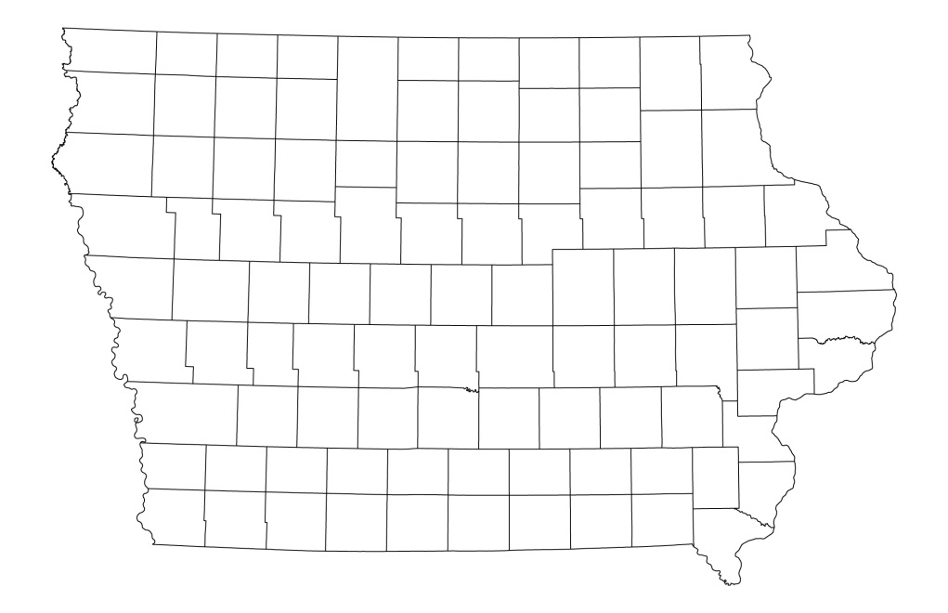

Drainage research site
Figure 1. Study site near Sutherland, Iowa.

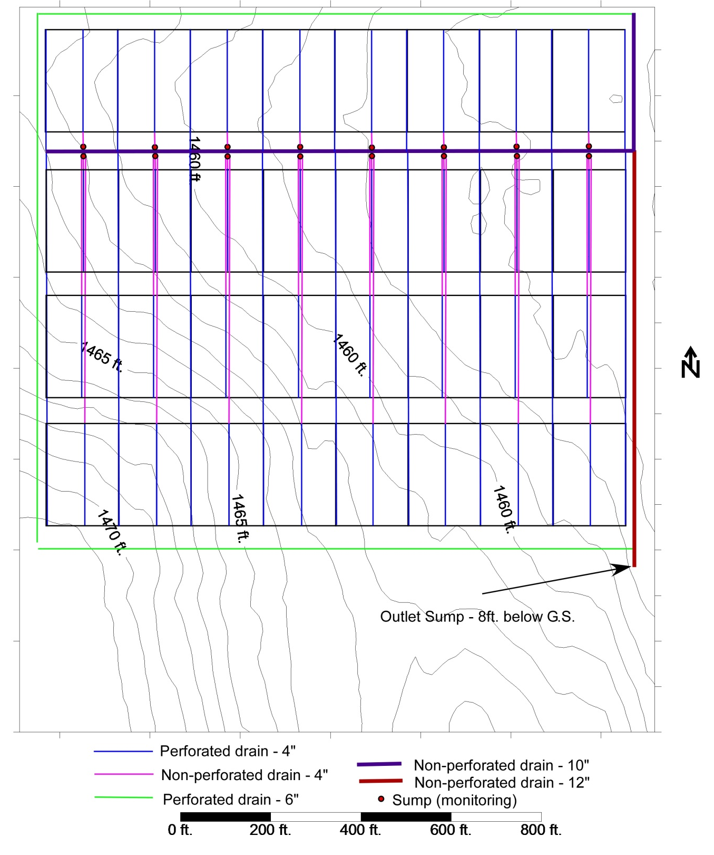
Figure 2. Subsurface overall drainage layout for study site, with elevation contour lines.

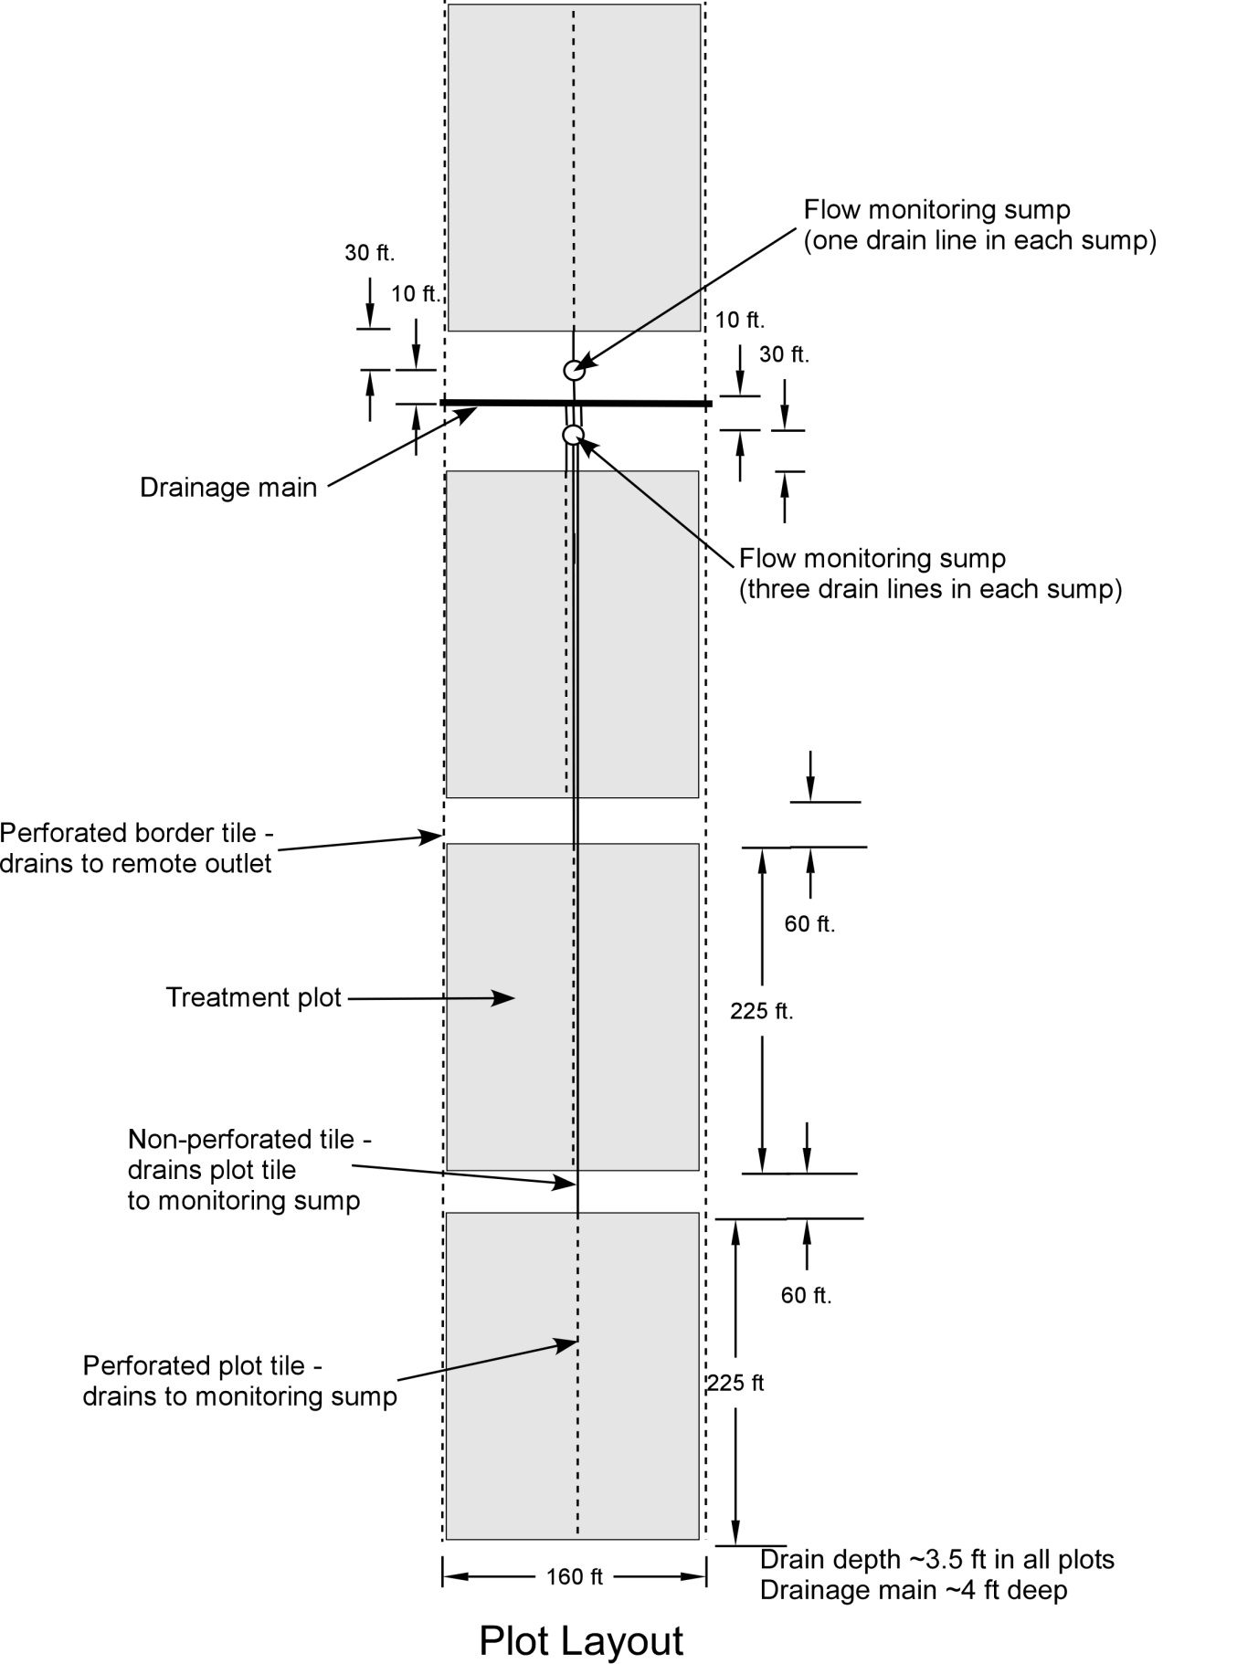
Figure 3. Subsurface drainage layout for four plots

IV. 2015-2016 Results
Except for the early fall 2014 freezing conditions which prevented fall anhydrous ammonia application (completed early spring 2015), agronomic operations were completed in a timely manner in 2015 and 2016 (Table 2). The 2015 year was characterized by greater precipitation in late summer and fall than would be normal for this geographic area (Table 3) and overall greater yearly precipitation than the 30-yr average precipitation (Cherokee, IA weather station which is about 10 miles south pf the project site). The 2016 crop year was also wetter than the 30-yr average precipitation with noticeably greater precipitation in April and September. The April precipitation delayed planting in 2016.
There was a 40 bu/acre yield increase with the use of N in treatments 1-3 as compared to treatment 4 where no N was applied (Table 4). In 2016, the yield increase with nitrogen application was greater than 50 bu/acre. During both 2015 and 2016, no statistically significant corn yield impacts were observed between the treatments where nitrogen was applied. Of note is that oats were uniformly grown across the site in 2013 and soybean in 2014. There were no statistical differences among the soybean yields in 2015 which would be expected based on the uniform previous site history, no treatments applied to soybean, and no prior-year N applications to corn. Soybean yields in 2016 were greater than 70 bu/acre for all treatments.
There were no statistically significant differences in flow-weighted nitrate-N concentrations between treatments where soybean was grown in 2015, which would be expected due to no nitrogen treatment application in the prior year (Table 5). In the corn phase in 2015, the treatment where no N was applied had statistically lower nitrate-N concentration than treatments where N was applied to corn. For 2016 in the corn phase, lower nitrate-N concentration with the no nitrogen treatment did not occur as in 2015 (no significant difference between with and without nitrogen application). In 2016 within the soybean phase, the treatment where no nitrogen was applied to the 2015 corn crop had statistically significant lower nitrate-N concentration than fall N treatment or the spring N preplant treatment. For both years in the corn phase, and in 2016 in the soybean phase, the nitrate-N concentration was the same for the control and the split N application. Additional years of water quality data will provide important information to continue to evaluate treatment effects over a longer time period with different weather conditions.
Overall, there were no statistically significant differences in TP or TRP concentrations between treatments (Tables 6 and 7). Based on comparing concentration of TP and TRP, it is evident most of the TP is in the TRP form.
We are continuing to summarize the crop sensing, stalk nitrate, grain N, and soil nitrate-N data that was collected in 2015 and 2016.

Project Dissemination
- June 15, 2016 – Presentation on “Nitrate reduction of 4R nitrogen management” at 4R Summit in Indianapolis, IN
- July 13, 2016 – Presentation on “Practices for nitrate-N reduction” at Northwest Research and Demonstration Farm Summer Field Day near Sutherland, IA (75 attendees)

Table 2. Dates of field operations for corn.
 | 2015 | 2016
Fall NH₃-N application | April 1 | November 10 2015
Spring NH₃-N application | April 4 | April 12
Planting date | May 4 | May 19
Urea starter banded at planting | May 4 | May 19
Agrotain treated urea sidedress | July 9 | July 14
Harvest | October 13 | October 29
Sulfur application |  | November 3
Planting population (seeds/acre) | 34,000 | 34,000
Corn hybrid | Pioneer P0453 | AgriGold 6267VT2RIB

Table 3. Monthly precipitation and drainage in 2015 and 2016.
Month | Precip. in 2015 (in) | Precip. in 2016 (in) | 30-yr Avg. Precip. at Cherokee, IA (in) | Average Drain Flow (in)
 |  |  |  | 2015 | 2015 |  | 2016 |  | 2016
 |  |  |  | Corn |  | Soybean |  | Corn | Soybean
January | 0.1 | 0.2 | 0.6 | . |  | . |  | . | .
February | 0.0 | 0.4 | 0.6 | . |  | . |  | . | .
March | 0.6 | 2.1 | 1.9 | . |  | . |  | 0.7 | 1.4
April | 3.1 | 5.2 | 3.1 | 0.8 |  | 0.9 |  | 4.3 | 5.6
May | 3.5 | 3.5 | 3.9 | 0.9 |  | 0.5 |  | 2.8 | 4.0
June | 2.6 | 1.8 | 5.0 | 0.2 |  | 0.0 |  | 0.0 | 0.1
July | 6.8 | 3.9 | 3.9 | 0.2 |  | 0.1 |  | 0.1 | 0.6
August | 6.1 | 3.2 | 3.7 | 0.7 |  | 0.2 |  | 0.0 | 0.0
September | 2.8 | 7.5 | 3.5 | 0.5 |  | 0.2 |  | 5.2 | 5.6
October | 1.9 | 3.5 | 2.1 | 0.3 |  | 0.0 |  | 1.2 | 2.0
November | 4.9 | 1.8 | 1.5 | 4.6 |  | 4.3 |  | 0.3 | 0.7
December | 1.8 | 1.0 | 0.9 | 3.6 |  | 2.8 |  | 0.0 | 0.1
Total | 34.1 | 34.0 | 30.7 | 11.8 |  | 9.0 |  | 14.6 | 20.2

Table 4. Crop yields (bu/acre) for 2015 and 2016.
 |  | 2015 |  |  |  | 2016
Treatment | Nitrogen Management for Corn | Corn |  | Soybean |  | Corn |  | Soybean
1 | Fall NH₃ (with inhibitor) | 221 | a* | 62.2 | a | 198 | a | 74.0 | ab
2 | Spring NH₃ (no inhibitor) | 223 | a | 64.1 | a | 200 | a | 75.0 | a
3 | Split N | 224 | a | 64.2 | a | 196 | a | 72.4 | b
4 | None | 183 | b | 61.3 | a | 141 | b | 73.6 | ab
*Means with the same letter in the same column are not significantly different, P=0.05.

Table 5. Flow-weighted nitrate-N concentrations (mg/L).
 |  | 2015 |  |  |  | 2016
Treatment | Nitrogen Management for Corn | Corn |  | Soybean |  | Corn |  | Soybean
1 | Fall NH₃ (with inhibitor) | 16.2 | a* | 12.7 | a | 12.7 | a | 13.2 | a
2 | Spring NH₃ (no inhibitor) | 15.7 | a | 13.4 | a | 12.1 | a | 13.7 | a
3 | Split N | 12.0 | ab | 12.1 | a | 10.1 | a | 11.1 | ab
4 | None | 9.1 | b | 12.5 | a | 9.7 | a | 7.6 | b
*Means with the same letter in the same column are not significantly different, P=0.05.

Table 6. Flow-weighted total phosphorus concentrations (mg/L).
 |  | 2015 |  |  |  | 2016
Treatment | Nitrogen Management for Corn | Corn |  | Soybean |  | Corn |  | Soybean
1 | Fall NH₃ (with inhibitor) | 0.022 | a* | 0.020 | a | 0.020 | a | 0.016 | a
2 | Spring NH₃ (no inhibitor) | 0.026 | a | 0.019 | a | 0.018 | a | 0.021 | a
3 | Split N | 0.022 | a | 0.019 | a | 0.019 | a | 0.016 | a
4 | None | 0.020 | a | 0.020 | a | 0.017 | a | 0.014 | a
*Means with the same letter in the same column are not significantly different, P=0.05.

Table 7. Flow-weighted total reactive phosphorus concentrations (mg/L) for 2015 and 2016.
 |  | 2015 |  |  |  | 2016
Treatment | Nitrogen Management for Corn | Corn |  | Soybean |  | Corn |  | Soybean
1 | Fall NH₃ (with inhibitor) | 0.022 | a* | 0.017 | a | 0.019 | a | 0.017 | a
2 | Spring NH₃ (no inhibitor) | 0.024 | a | 0.020 | a | 0.017 | a | 0.020 | a
3 | Split N | 0.026 | a | 0.019 | a | 0.019 | a | 0.016 | a
4 | None | 0.021 | a | 0.020 | a | 0.017 | a | 0.014 | a
*Means with the same letter in the same column are not significantly different, P=0.05.

References
Baker, J.L., M.B. David, D.W. Lemke, and D.B. Jaynes. 2008. Understanding nutrient fate and transport. pp. 1-17 in Gulf Hypoxia and Local Water Quality Concerns Workshop, ASABE Pub #913C0308.
Crumpton, W.G., T.M. Isenhart, and P.D. Mitchell. 1992. Nitrate and organic N analyses with second-derivative spectroscopy. Limnology and Oceanography, 37:907-913.
Dale, V.H., C. Kling, J.L. Meyer, J. Sanders, H. Stallworth, T. Armitage, D. Wangsness, T.S. Bianchi, A. Blumberg, W. Boynton, D.J. Conley, W. Crumpton, M.B. David, D. Gilbert, R.W. Howarth, R. Lowrance, K. Mankin, J. Opaluch, H. Paerl, K. Reckhow, A.N. Sharpley, T.W. Simpson, C. Snyder, D. Wright. 2010. Hypoxia in the Northern Gulf of Mexico. Springer, New York, 284 pages.
David, M.B., L.E. Gentry, D.A. Kovacic, and K.M. Smith. 1997. Nitrogen balance in and export from an agricultural watershed. J. Environ. Qual. 26:1038–1048. doi:10.2134/jeq1997.00472425002600040015x.
Keeney, D.R., and T.H. DeLuca. 1993. Des Moines river nitrate in relation to watershed agricultural practices: 1945 versus 1980’s. J. Environ. Qual. 22:267–272. doi:10.2134/jeq1993.00472425002200020006x.
Lawlor, P. A., M.J. Helmers, J. L. Baker, S. W. Melvin, and D. W. Lemke. 2008. Nitrogen
application rate effects on nitrate-nitrogen concentrations and losses in subsurface drainage. Trans. ASABE 51(1): 83-94.
Lowrance, R. 1992. Nitrogen outputs from a field-size agricultural watershed. J. Environ. Qual. 21:602–607. doi:10.2134/jeq1992.00472425002100040013x.
Murphy, J and J. Riley, 1962. A modified single solution method for the determination of phosphate in natural waters. Anal. Chem. Acta. Vol. 27 page 31.
Rabalais, N.N., R.E. Turner, and W.J. Wiseman, Jr. 2001. Hypoxia in the Gulf of Mexico. J. Environ. Qual. 30:320–329. Doi: 10.2134/ jeq2001.302320x.
Zucker, L.A., and L.C. Brown. 1998. Agricultural drainage: Water quality impacts and subsurface drainage studies in the Midwest. Ohio State Univ. Ext. Bull. 871. The Ohio State University, Columbus.

