Annual Report

Evaluating the 4R Nutrient Stewardship Concept and Certification Program in the Western Lake Erie Basin

Submitted by

Kevin King
1/25/2017

Interpretive Summary: Since the mid 1990s, soluble phosphorus (P) entering Lake Erie has steadily increased, promoting harmful and nuisance algal blooms (HNABs). The focus of this excess P delivery has been on agriculture. The 4R principles of nutrient stewardship have been promoted in the WLEB and adoption is gaining momentum with nearly 2,000,000 acres within the Western Basin being managed by one of 37 4R certified retailer/service providers. However, understanding and quantifying the water quality benefits of the 4R program need to be accomplished. A multifaceted research project was initiated in July 2014 to quantify the edge-of-field and watershed scale effects of the 4R program. The project includes: data collection from edge-of-field and watershed scales; watershed and in-lake modeling; a socioeconomic assessment of producers; a triple bottom line assessment of the 4R program including a survey of retailers; and education and outreach. Three paired edge-of-field (EOF) data collection sites have been established and 15 additional EOF site within and outside of the WLEB have been leveraged for assessment of best management practices including the 4Rs. A broad brush assessment of prevailing management practices on those EOF sites indicates that the 4R practices are directionally correct for reducing P to WLEB. Watershed scale assessments will be based on water quality data collection through the National Center for Water Quality Research, which has been in place since the mid 1970s. Initial assessments indicate that a comparison between watersheds is possible; however, given the widespread extent to which the 4R initiative has been adopted, the watershed analysis will be based on percentage of acres affected within each watershed. SWAT models for three major watersheds that comprise the WLEB have been populated and different scenarios have and are being run to project and assess the benefits of the 4R initiative. A second producer survey within the WLEB basin was completed and analyzed. Findings indicate that a majority (>80%) of producers are aware of the 4R initiative and between 60% and 90% are willing to adopt a new management practice. However, economic barriers may prevent the adoption of some practices. Additionally, outreach and promotion of the 4R program have occurred at multiple meetings and venues.

Objective 1: To monitor the impacts of 4R Nutrient Stewardship practices and the 4R Certification Program on crop productivity, nutrient losses, and biotic integrity from select fields, streams, and watersheds in the WLEB.

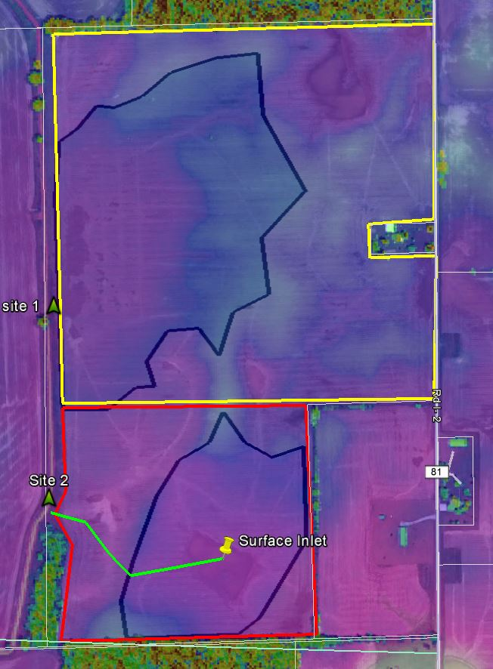
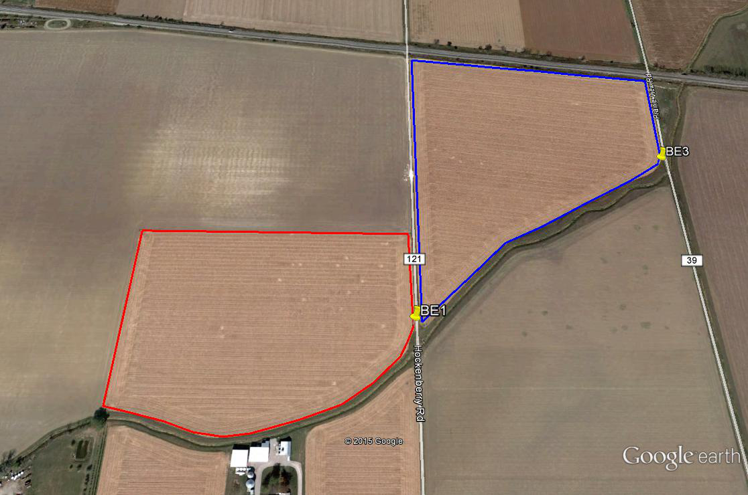
C
A
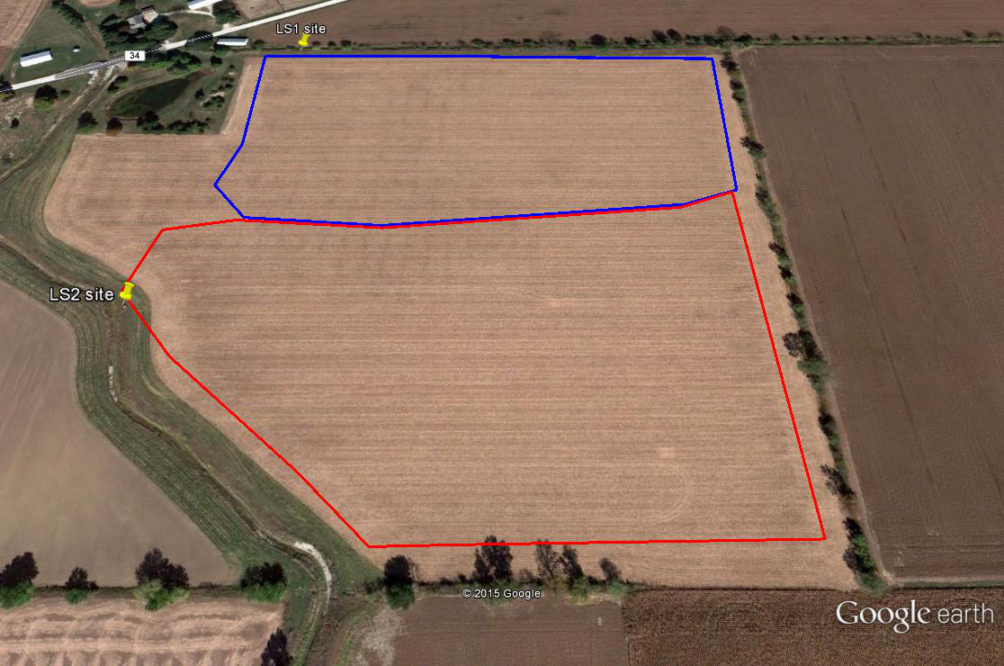
B
Figure 1. Outline of fields in Ohio (A&B) and Indiana (C) being used for edge-of-field monitoring to support the 4R Research Project.
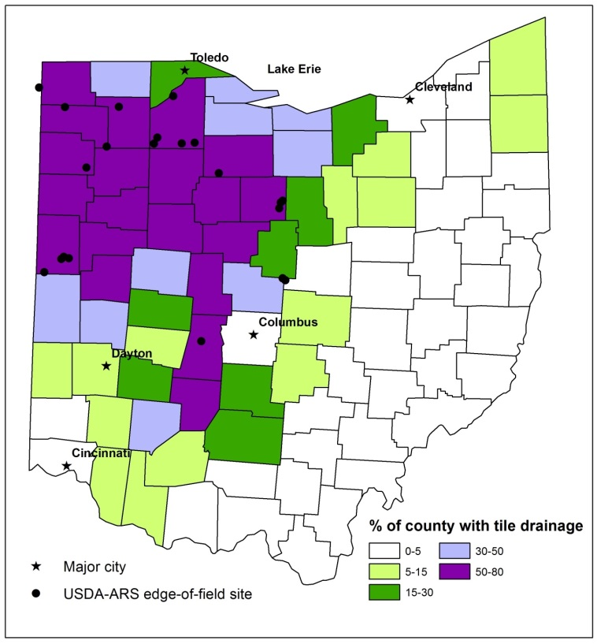
Figure 2. Location of paired, 4R and leveraged ARS EOF sites being used to assess 4R practices.

Edge-of-Field (EOF) Monitoring: Two sites in Ohio and one in Indiana were identified for combined surface and subsurface EOF monitoring (Figure 1A, 1B, and 1C). The Ohio sites are located in Wood County in the Portage River Watershed. The Indiana site is located in Steuben County on the Ohio-Indiana border. All three sites are representative of crop production agricultural systems in the tile drained landscape of the WLEB. Instrumentation was completed at the Ohio sites in Jan/Feb 2015 and the Indiana site in Nov/Dec 2015. In addition to these three sites, additional EOF sites (Figure 2) also have 4R related research ongoing and those data are being leveraged as part of this research effort.

Data collection continues from 20 paired EOF sites. Example of hydrology and water quality data can be found in Figure 3 (Indiana site) and Figure 4 (Ohio BE EOF sites). Data suggests that a significant amount of DRP load originates in the tile drainage. Several publications have been submitted and published in the prior year. One publication (#9 in list at end of this section) submitted to J. Soil and Water Conservation speaks directly to the impact of 4R practices. That paper, however, has not yet been accepted for publication. Data analysis is ongoing to relate 4R and other practices to water quality signatures.

Figure 3. 2016 discharge (L/s) data from surface and tile sites at Indiana paired field location.

Figure 4. Preliminary time series EOF data from BE site in Ohio.

Manuscripts and presentations led by or had contributions from Kevin King and Mark Williams related to EOF component:
Peer Reviewed:
      - Williams, M.R., K.W. King, W.I. Ford, A.R. Buda, and C.D. Kennedy. Effect of tillage on macropore flow and phosphorus transport to tile drains. Water Resources Research 52: 2868-2882. 2016. [“right place” (incorporating surface-applied P fertilizer as compared to leaving it on the surface of a no-till field) reduced the dissolved P concentration in tile discharge by 45%]
      - Christianson, L.E., R.D. Harmel, D.R. Smith, M.R. Williams, and K.W. King. A quantitative review and synthesis of fifty years of drainage phosphorus losses. J. Environ. Qual. doi:10.2134/jeq2015.12.0593. 2016. [This publication was a product of another 4R Fund project (IPNI-2014-USA-4RM04 – at http://research.ipni.net/page/RNAP-6590). The practice of no-till significantly increased drainage dissolved P loads compared with conventional tillage]
      - King, K.W., M.R. Williams, W.A. Dick, and G. LaBarge. Decreasing phosphorus losses in tile-drained landscapes using flue gas desulfurization gypsum. J. Environ. Qual. doi:10.2134/jeq2016.04.0132. 2016. [“right source” - where soil test P levels are very high (>480 ppm Mehlich-3) surface application of flue gas desulfurization byproduct gypsum can be used as a tool to address elevated P concentrations and loadings in drainage waters.]
      - Moriasi, D.N., K.W. King, D.D. Bosch, D.L. Bjorneberg, S. Teet, J.A. Guzman, and M.R. Williams Framework to parameterize and validate APEX to support deployment of the nutrient tracking tool. Ag Water Management 177:146-164. [Provides modeling framework for assessing “right source, rate, time and place”. Not all scenarios can be tested in a field study so simulation tools permit an assessment of practices]
      - Williams, M.R., K.W. King, G.A. LaBarge, R. Confesor, and N.R. Fausey. Edge-of-field evaluation of the Ohio phosphorus risk index. J. Environ. Qual. doi:10.2134/jeq2016.05.0198. [Current Ohio P Index needs revision to accurately identify “right” P application timing and other management practices. Such revision requires calibration and validation to measured field data.]
      - Ross, J.A., M.E. Herbert, S.P. Sowa, J.R. Frankenberger, K.W. King, S.F. Christopher, J.L. Tank, J.G. Arnold, M.J. White, and H. Yen. A synthesis and comparative evaluation of drainage water management. Ag Water Management 178:366-376. [many 4R practices will be implemented in combination with drainage water management. Knowing the impacts of DWM will permit a better quantification of the 4R practice being studied]
      - Ford, W.I., K.W. King, M.R. Williams, R. Confesor. 2016. Simulating macropore phosphorus contributions to tile drains using APEX. Journal of Environmental Quality doi:10.2134/jeq2016.06.0218. [Modifying the APEX model to include macropore flow was critical to its ability to simulate P loss.]
      - King, K.W., M.R. Williams, G.A. LaBarge, D.R. Smith, J.M. Reutter, E.W. Duncan, and L.A. Pease. Addressing agricultural phosphorus loss in artificially drained landscapes with 4R nutrient management practices. J. Soil and Water Conservation (submitted 11-6-2016). [paper has not yet been accepted but does provide a broad brush assessment of all 4R practices in relation to EOF data in Ohio]
      - King, K.W., M.R. Williams, L.T. Johnson, D.R. Smith, G.A. LaBarge, and N.R. Fausey. 2017. Phosphorus availability in Western Lake Erie Basin drainage waters: legacy evidence across spatial scales. J. Environ. Qual. (accepted 1-23-17). [In determining ‘right rate’ accounting for legacy P is critical for reducing losses]

Popular Press:
- Interview and contribution towards “6 tips for keeping ‘P’ in fields and out of local water sources” posted on October 29, by Laura Barrera, No-till Farmer.

Presentations:

- Jan 7 - provided presentation (Measuring Nutrient Loss in Edge-of-Field Surface and Tile Drainage) at the National No-Till Conference in Indianapolis, IN (900 to 1000 national and international no-till producers)
- Jan 22 – provided presentation (Water Quality and Phosphorus Management) at the 2016 Corn/Soybean Day in Archbold, OH (300 producers)
- Jan 27 – provided presentation (Edge-of-Field Research: Not all Fields are the Same) at the 2016 Great Lakes Crop Summit in Mount Pleasant, MI (250 to 300 producers)
- Feb 9 – provided presentation/discussion (Current Edge-of-Field Research Findings) to Frazier Heiby (public relations group for Ohio Corn and Wheat Growers) in Columbus, OH (2 representatives).
- Feb 10 – provided presentation (Water Quality Monitoring) at the 2016 Ohio Pork Congress in Columbus, OH (20 CCAs/producers).
- Feb 18 – provided presentation (Edge-of-Field Water Quality Research: Not all Fields are the Same) at the Solutions from the Farm: Opportunities to Reduce Nutrient Loss grower workshop in Pauling, OH (75 producers and extension).
- March 3 – made presentation (Update on edge-of-field research and conservation practice assessment) at the Conservation Tillage Conference in Ada, OH (200 to 250 producers, crop consultants, and extension)
- March 15 – made presentation (The role of tile drainage in P transport and the impact of gypsum, cover crops, and DWM in reducing losses) at the Healthy Soil – Healthy Waters: Soil Health Grower Meeting in New Haven, IN (50 producers)
- March 22 – made presentation (Edge-of-field research: what is the data telling us right now) at the WLEB stakeholder meeting in Columbus, OH (25 stakeholders, commodities, university, and NGOs)
- March 29 – Provided presentation (Update on edge-of-field research approach and findings) and field tour at the OSU Extension Day in London, OH (35-40 OSU extension specialists).
- May 13 – provided field presentation (Watershed and Edge-of-Field Research) to 40 Ohio State University graduate students and faculty (Centerburg, OH).
- May 17 – provided presentation (Edge-of-field research: past, present, future) to 25 members of NCERA 180: Precision Ag Group (London, OH).
- June 13 – provided presentation (Watershed and Edge-of-Field Research: What is the data telling us now) to 25 NRCS Area 5 engineers and technicians (Delaware, OH).
- June 15 –provided presentation (Evaluating the 4R Nutrient Stewardship Concept and Certification Program in the Western Lake Erie Basin) to 80 industry, stakeholders, and researchers at 4R Summit (Indianapolis, IN).
- July 7 - provided a seminar (Production agriculture and environmental targets: can they coexist?) to 40 faculty, staff, and students at Purdue University, West Lafayette, IN.
- Aug 16 – provided EOF research summary at Seneca County Field Day to approximately 30 producers
- Aug 23 – provided EOF research summary to 30 elected officials and producers at Crawford County Elected Officials tour
- Aug 26 – provided EOF research summary and recommendations to 75 producers in Hardin and surrounding counties
- Sept 15 –made presentation (Using edge-of-field research to assess agricultural management practices) at State of Science: Harmful Algal Bloom conference in Toledo, OH (300 stakeholders)
- Sept 20, 21, 22 –made 8 field day presentations (Edge-of-field research to address nutrient loss) at Farm Science Review (100 producers and stakeholders)
- Sept 30 –provided consultation to Michigan Corn Growers and Michigan Agribusiness and Michigan Farm Bureau on edge-of-field findings and provided guidance on practices most likely to reduce nutrient movement from agricultural lands.
- November 6 - Made presentation “Edge-of-field evaluation of the Ohio phosphorus risk index” at the ASA, SSSA, CSA (Tri-Society) meeting in Phoenix, AZ (45 researchers and extension)
- November 14 – Made in field presentation “What are we learning from edge-of-field studies” and provided field tour of edge-of-field research site near Cygnet, OH (90 producers, municipalities, mayors, extension, researchers, congressional representatives)
- November 17 - Made presentation “Agricultural best management practices” at the Agriculture: Economy and Ecology Conference in Perrysburg, OH (80 local government, producers, policy makers, extension, industry representatives)
- Dec 20 – provided a presentation (Using Edge of Field Research to Assess Agricultural Management Practices) 40 to 50 industry, producers, NGOs at the Ohio Grain Farmers Symposium (Columbus, OH).

Watershed Monitoring and Biotic Measurements:
Accomplishments
- Deployed, calibrated, and maintained two YSI EXO2 sondes collecting dissolved oxygen, pH, turbidity, temperature, and conductivity data at the Sandusky and Portage River sampling locations; deployed miniDOT sensors collecting dissolved oxygen and temperature data at the Blanchard, Tiffin, Maumee, Rock, and Honey sampling locations; and deployed Odyssey PAR sensors at each of the above stations. We decided to deploy these sensors to pair with existing watershed data to look at the influence of 4R certification on stream biological activity. The sensors were not placed in the edge-of-field ditches this past summer due to drought (i.e., the ditches were dry).
- Conducted preliminary data analysis of the need for 4Rs in select watersheds and used this information to pair with data from the edge-of-field locations. These data were presented at the IAGLR conference (see below).
- The 2016 water year data collection was recently updated for all HTLP watersheds, including those data used in this project. Data are available for download at www.heidelberg.edu/ncwqr
Synergistic Activities
- Facilitated on a nutrient bus tour organized by Seneca and Wood County Conservation Districts. The goal of the tour was to show people common nutrient sources, including farm fields, waste-water treatment lagoons, dairy farms, agricultural retailers, and a sediment dredge recycling location. Over 80 people attended including politicians, students, farmers, and citizens. November 14, 2016.
- Co-hosted a water quality forum and open house at Heidelberg University to bring together all sectors of water in Seneca County. Forum participants included the Sandusky River Watershed Coalition, ODNR Scenic Rivers, Aqua America (Tiffin’s drinking water facility), and the Tiffin Water Pollution Control Center. 21 October 2016.
Manuscripts
- Williams, M.R., K.W. King, D.B. Baker, L.T. Johnson, D.R. Smith, and N.R. Fausey. 2016. Hydrologic and biogeochemical controls on phosphorus export from Western Lake Erie tributaries. Journal of Great Lakes Research 42(6): 1403-1411. [Dissolved P loads increase with watershed discharge. P transport behavior is similar to that of other geogenic constituents like silica, suggesting that the source of the P is large and ubiquitous].
- Baker, D.B., L.T. Johnson, R.B. Confesor, and J.P. Crumrine. 2017. Vertical stratification of soil phosphorus as a concern for dissolved phosphorus runoff in the Lake Erie basin. Journal of Environmental Quality. doi:10.2134/jeq2016.09.0337. [The mean soil test P in the top inch of soil was 55% higher than that in the sample taken to a typical agronomic depth. Reducing stratification on the majority of soils is important to achieving watershed scale P loss reductions.]
- Jarvie, H.P., L.T. Johnson, A.N.Sharpley, D.R. Smith, D.B. Baker, T.W. Bruulsema, and R.Confesor. 2017. Journal of Environmental Quality. 46:123–132. [Attributes one-third of increased dissolved P delivery to Lake Erie to increased river flow. Points to changes in tile drainage intensity and conservation tillage systems as possible partial explanations for the remaining two-thirds, and shows that since the cropland P balance is trending toward deficit, excess rate of P application is not a plausible cause.]
- Stumpf R.P., L.T. Johnson, T.T. Wynne, D.B. Baker. 2016. Forecasting annual cyanobacterial bloom biomass to inform management decisions in Lake Erie. Journal fo Great Lakes Research. 42: 1174-1183. [relates size of the algal bloom to bioavailable P loading (emphasizing importance of dissolved P) from the Maumee river.
- MacDonald, G.K., H.P. Jarvie, P.J.A. Withers, D.G. Doody, B.L. Keeler, P.M. Haygarth, L.T. Johnson, R.W. McDowell, M.K. Miyittah, S.M. Powers, A.N Sharpley, J. Shen, D.R. Smith, M.N. Weintraub, and T. Zhang. 2016. Guiding phosphorus stewardship for multiple ecosystem services. Ecosystem Health and Sustainability. 2(12):e01251. 10.1002/ehs2.1251 [This paper in Figure 1 clearly shows source, rate, time and place of P use – P input stewardship – to be fundamental to multiple ecosystem services.]
Presentations
MOST IMPORTANT ONES:
- 9 February 2016. Evaluating the 4R nutrient stewardship concept and certification program in the Western Lake Erie Basin. The Fertilizer Institute Annual Meeting. Orlando, Florida.
- 9 June 2016. Linking 4R nutrient stewardship at the farm to water quality from the field to watershed. International Association of Great Lakes Research Annual Conference. Guelph, Ontario.

Other related presentations.
- 14 December 2016. Water quality trends from 2016. Ohio Lake Erie Commission Meeting, Delaware, Ohio.
- 5 December 2016. Water Quality: What the data tells us. Area 4 Ohio Soil and Water Conservation District Winter meeting. Dayton, Ohio.
- 18 November 2016. Phosphorus and Lake Erie: Sources and trends. Blanchard River Demonstration Farm Bus Tour. Findlay, Ohio.
- 14 November 2016. Lake Erie algae and phosphorus: Trends and sources. Nutrient Bus Tour hosted by Seneca and Wood County Conservations Districts. Gibsonburg, Ohio.
- 14 September 2016. The Heidelberg Tributary Loading Program: Keeping a finger on the pulse of Ohio’s watersheds. Toledo, Ohio.
- 21 October 2016. The Heidelberg Tributary Loading Program: Connecting land, streams, lakes, and algal blooms. Public Forum: How clean is our water? Heidelberg University, Tiffin, Ohio.
- 6 October 2016. Phosphorus and Lake Erie: Perspectives from between the land and lake. Kent State University Water Symposium, Kent, Ohio.
- 19 September 2016. Where is the phosphorus coming from? Seneca Conservation District Practical Talks for Farmers. Tiffin, Ohio.
- 18 August 2106. Comparing nutrient export across watersheds. OSU Stone Lab and Ohio Sea Grant Science Writers Workshop. Gibraltar Island, Ohio.
- 15 August 2016. The Heidelberg Tributary Loading Program: Trends from the Maumee River. Great Lakes HABs Collaboratory Webinar.
- 4 August 2016. The Heidelberg Tributary Loading Program: Keeping a finger on the pulse of Ohio’s watersheds. North American Manure Expo, London, Ohio.
- 2 August 2016. Phosphorus and Lake Erie: Perspectives from between the land and lake. Lakeside Chautauqua seminar series, Lakeside, Ohio.
- 9 July 2016. Panel member of an Environmental Roundtable on Water Quality Update on Lake Erie and NW Ohio Watersheds hosted by US Senator Rob Portman.
- 7 July 2016. Maumee nutrient loading: March 1 – July 31, 2016. Western Lake Erie HAB Seasonal Forecast. OSU Stone Lab and Ohio Sea Grant, Gibraltar Island, Ohio.
- 29 June 2016. Phosphorus and Lake Erie: Where is it coming from? River Raisin Institute Board Retreat. Monroe, Michigan.
- 20 June 2016. The Heidelberg Tributary Loading Program: Keeping a finger on the pulse of Ohio’s watersheds. Seneca County Tour for Model A Enthusiasts. Tiffin, Ohio.
- 13 May 2016. The Heidelberg Tributary Loading Program: Keeping a finger on the pulse of Ohio’s watersheds. Outdoor Writer’s Conference, Celina, Ohio.
- 29 March 2016. Phosphorus and Lake Erie: Perspectives from between the land and lake. Kenyon College. Gambier, Ohio.
- 18 March 2016. Phosphorus and Lake Erie: Perspectives from between the land and lake. Lake Erie Waterkeeper Conference. Perrysburg, Ohio.
- 14 March 2016. The Heidelberg Tributary Loading Program: Keeping a finger on the pulse of Ohio’s watersheds. Ohio Soil and Water Conservation Society. Reynoldsburg, Ohio.
- 10 March 2016. Phosphorus and Lake Erie: Where is it coming from? Western Lake Erie Cluster Public Forum. Monroe, Michigan.
- 24 February 2016. Phosphorus and Lake Erie: Where is it coming from? Great Lakes Symposium at the Toledo Zoo. Toledo, Ohio.

Objective 2: To model the environmental benefits in Lake Erie (turbidity and HABs) following various levels of implementation of 4R Nutrient Stewardship practices and the 4R Certification Program in three WLEB agricultural watersheds.

Maumee River Basin SWAT and WLEEM Model (LimnoTech: Todd Redder):
General Notes:
- SWAT model development, calibration, and application activities have also been supported by grants provided by the Erb Family Foundation and the Ohio Department of Higher Education (HABRI initiative), as well as by a project funded by Field to Market® (related to its Fieldprint® calculator).
- “Western Lake Erie Ecosystem Model” (WLEEM) development, calibration, and application activities have been co-supported by several other projects funded by NSF, CSMI, and USEPA.
Soil & Water Assessment Tool (SWAT) – Maumee River Basin
- Model development & calibration:
  - Model simulation period extended through calendar year 2015 in order to capture the most recent conditions and better utilize the Heidelberg University daily nutrient loading data available for the Tiffin River (Stryker, OH) and the Blanchard River (Findlay, OH) beginning in summer 2007.

  - Model inputs were updated during summer 2016 to reflect latest findings and survey information from recent data sources, such as the CEAP report (USDA-NRCS 2016), NSF manure surveys, NuGIS, and surveys conducted by project team members at Ohio State University. Specific inputs that were updated include:
    - Quantity and (vertical) place of commercial fertilizer and manure;
    - Timing of commercial fertilizer and manure applications (i.e., spring vs. fall); and
    - Adoption rate of BMPs in Maumee basin, including fertilizer incorporation (vs. broadcast), buffer strips, and cover crops.

  - SWAT model was re-calibrated to 2010-2015 time period and then validated to 2005-2009 period based on data available from the following sources:
    - Hydrology: Multiple USGS flow gages, including Waterville, OH gage and at least one gage for each major tributary to the Maumee River (i.e., St. Joseph, St. Marys, Tiffin, Auglaize).
    - Water Quality: Heidelberg University water quality datasets at:
      - Maumee River at Waterville, OH (full calibration period)
      - Tiffin River at Stryker, OH (2007-present)
      - Blanchard River at Findlay, OH (2007-present)

- Application to BMP scenarios:
  - As of December 2016, we are actively working on running an additional suite of BMP scenarios, including several scenarios with a 4R focus (primarily related to placement and timing - see scenarios 3, 4, 5, and 9 in Attachment 1).

- Model integration & testing with edge of field (EOF) datasets:
  - Beginning in August 2016, worked with Dr. Kevin King and his team to acquire EOF datasets and management information for calendar year 2015 for several EOF sites in Ohio.

  - Conducted initial configuration and testing of SWAT model for a limited number of sites in fall 2016. We will be expanding this work throughout 2017, working closely with Dr. King and his team on data interpretation and conceptual model development.

  - Documentation of initial EOF modeling efforts is documented in Attachment 2, which is excerpted from a draft report submitted to the Field to Market® organization (in support of a complementary, but separate project).

- Publication:
  - Co-authored a publication for the SWAT model results generated for 4R-related scenarios and other BMP scenarios published in Frontiers (Scavia et al., in press).

Western Lake Erie Ecosystem Model (WLEEM)
- Model application & sensitivity analysis:
  - Conducted revised simulations for loading reductions of 0% (baseline), 25%, 50%, and 75% for Maumee River total phosphorus load and used results to update a load-response curve relating harmful algal bloom (HAB) biomass to “spring” (March-July) total phosphorus loading from the Maumee River.
  - Conducted sensitivity analysis with model to explore impact of key algal growth and sediment-related parameters on predicted cyanobacteria biomass.

- IAGLR presentation – WLEEM model application results were presented at the IAGLR 2016 annual conference in a talk entitled “Western Lake Erie Ecosystem Model: An operational model for the scientific and management community.” (abstract is provided as Attachment 3).

- Publication:
  - A paper titled “Development of the Western Lake Erie Ecosystem Model (WLEEM): Application to connect phosphorus loads to cyanobacteria biomass” was published in the December issue of the Journal of Great Lakes Research (Verhamme et al., 2016).

Attachments:
- Listing of Maumee basin BMP scenarios being evaluated using LimnoTech’s SWAT model for the Maumee basin.

- Report excerpt describing the approach and outcome for an initial SWAT application to data for edge of field site “BE” (based on data provided by Dr. Kevin King).

- Abstract from WLEEM presentation given at IAGLR 2016 conference.

References:
Scavia, D., M. Kalcic, R. Logsdon Muenich, N. Aloysius, I. Bertani, C. Boles, R. Confesor, J. DePinto, M. Gildow, J. Martin, J. Read, T. Redder, D. Robertson, S. Sowa, Y. Wang, H Yen. Multiple SWAT models guide strategies for agricultural nutrient reductions. Frontiers in Ecology and the Environment. in press
U.S. Department of Agriculture Natural Resources Conservation Service (USDA-NRCS). (2016), Effects of Conservation Practice Adoption on Cultivated Cropland Acres in Western Lake Erie Basin, 2003-06 and 2012Rep., 120 pp, U.S. Department of Agriculture, Natural Resources Conservation Service, Washington, D.C.
Verhamme, E.M., T.M. Redder, D.A. Schlea, J. Grush, J.F. Bratton, and J.V. DePinto. “Development of the Western Lake Erie Ecosystem Model (WLEEM): Application to connect phosphorus loads to cyanobacteria biomass.” Journal of Great Lakes Research, 42:6, December 2016, pp. 1193-1205. URL: http://www.sciencedirect.com/science/article/pii/S0380133016301770.

Objective 3: To determine the behavioral impact of 4R educational efforts and the 4R Certification Program on the knowledge, beliefs, and management practices of crop growers and nutrient service providers in the WLEB.
- Administered the survey in winter 2016 (survey attached).
- Entered and cleaned up the data in spring 2016,
- Spent the summer doing preliminary analyses and developing the policy report
- Working to clean up the report throughout the fall while seeking feedback from the project team (preliminary report attached).

Presentations related to this data from the past year:
R.S. Wilson. 2016. “Modeling the effectiveness of outreach as a risk management tool”. Presented at the Society for Risk Analysis Annual Meeting, San Diego, California, United States.
R.S. Wilson. 2016. “Farmer BMP adoption: Possible futures and the efficacy gap”. Presented at Understanding HABs: State of the Science Conference, Toledo, Ohio, United States.
R.S. Wilson. 2016. “What motivates farmers to apply phosphorus at the “right” time? Survey evidence from the western Lake Erie basin.” Presented at the Stone Lab Guest Lecture Series, Put-in-Bay, Ohio, United States.

Objective 4: To conduct a triple bottom line (TBL) evaluation of the economic, social, and environmental performance of the 4R Nutrient Stewardship Program in the WLEB.

The Cost-Benefit Analysis for the 4R Nutrient Stewardship Certification Program is being finalized. The final elements involve:
- conducting sensitivity analyses and
- articulating several possible scenarios that would illustrate a set of behavioral and geo-physical relationships that would result in benefits and costs of the program equating.

Editing of the final report has begun and will continue as the sensitivity analyses and illustrative scenarios are added.
Attached are five power point slides documenting the findings at this point (Switch NSP.pptx).

Objective 5: To integrate information from all the above to develop indicators for continued public reporting of progress and guide the 4R Nutrient Stewardship Certification Program
- Sharing the data and information with the farming community, other researchers, the 4R Nutrient Stewardship Council and elected officials is important. Several field days were hosted to inform producers about 4R practices. Website is updated as information becomes available.
- 4R Nutrient Stewardship Council meetings have an update and discussions regarding progress, outcomes, and timelines of the research project.
- Plans are being made to develop several videos highlighting the research project and findings.
- Publication: Vollmer-Sanders, C., A. Allman, D. Busdeker, L.B. Moody, and W. G. Stanley. 2016. Building partnerships to scale up conservation: 4R Nutrient Stewardship Certification Program in the Lake Erie watershed. J. Great Lakes Research 42: 1395-1402.

Project Management:
- Conducted periodic team conference calls and a face to face meeting with research team.

